### CFD ANALYSIS OF BLOOD FLOW THROUGH STENOSED CAROTID ARTERY USING FLUID-STRUCTURE INTERACTION (FSI)

### 

**FINAL YEAR PROJECT UG 2025**

By

Muhammad Rafay Khalid 00000388344

Saud Ishtiaque Ahmed 00000392954

Shaheer Farrukh Abbasi 00000384907

Muhammad Ameer Hamza 00000368358

Pakistan Navy Engineering College, Karachi

National University of Sciences and Technology, Islamabad, Pakistan

2025

**C E R T I F I C A T E**

This is to certify that the

Final Year Project Title

**CFD Analysis of Blood Flow through Stenosed Carotid Artery using Fluid-Structure Interaction (FSI)**

Submitted by

| Muhammad Rafay Khalid | 00000388344 |
| --- | --- |
| Saud Ishtiaque Ahmed | 00000392954 |
| Shaheer Farrukh Abbasi | 00000384907 |
| Muhammad Ameer Hamza | 00000368358 |

has been accepted towards the requirement for the undergraduate degree.

**In**

**MECHANICAL ENGINEERING**





**ANTI-PLAGIARISM CERTIFICATE**

This is to certify that the Final Year Project Report **CFD Analysis of Blood Flow through Stenosed Carotid Artery using Fluid-Structure Interaction (FSI)**

Submitted by

| Muhammad Rafay Khalid | 00000388344 |
| --- | --- |
| Saud Ishtiaque Ahmed | 00000392954 |
| Shaheer Farrukh Abbasi | 00000384907 |
| Muhammad Ameer Hamza | 00000368358 |

has been found 91% satisfactory as per the HEC requirement. The originality of this report generated by Turnitin Software is attached with the certificate.



**Content List**

**ABSTRACT 7**

**ACKNOWLEDGEMENT 8**

**CHAPTER 1 – INTRODUCTION 9**

**CHAPTER 2 – LITERATURE REVIEW 12**

2.1 Cardiovascular Systems 12

2.2 Fluid Properties of Blood 13

2.3 Pathobiological Basis of Atherosclerosis 14

2.3.1 Introduction 14

2.3.2 Pathophysiology of Atherosclerosis 15

2.3.3 Lesion in Atherosclerosis 15

2.3.4 Thrombosis in Atherosclerosis 17

2.3.5 Carotid Artery Stenosis 17

2.3.6 Plaque Features 18

2.4 Clinical Imaging 18

2.4.1 Medical Image Acquisition 19

2.4.2 Image Segmentation 20

2.4.3 Surface Reconstruction 22

2.5 Fluid Dynamics 24

2.5.1 Rheologial Models of Blood Flow 24

2.5.2 Role of Navier Stokes Equation in Blood Flow Simulations 26

2.5.3 Boundary Conditions for Inlet and Outlet in Arterial Models 27

2.6 Fluid Structure Interaction (FSI) Modelling in Blood Flow Analysis 29

2.6.1 Fluid Domain Setup 29

2.6.2 Solid Doain Setup 30

2.6.3 FSI Coupling Strategy in ANSYS Workbench 31

2.6.4 Impact of FSI on Predicted Hemodynamic Parameters 32

**CHAPTER 3 – Design Methodology** 33

3.1 CAD Geometry and Stenosis Growth 33

3.2 Computational Fluid Dynamic and Mesh Setup 35

3.2.1 Concept Development 35

3.2.2 Concept Finalization 39

**CHAPTER 4 – Results** 43

4.1 Mesh Independence Study 43

4.2 CFD Results for Healthy Carotid Artery (Benchmarked) 45

4.3 CFD Results on Stenosed Artery 51

4.3.1 25% Stenosis 51

4.3.2 50% Stenosis 55

4.3.3 75% Stenosis 58

4.4 FSI Results 61

4.4.1 Healthy Artery 61

4.4.2 25% Stenosis 63

4.4.3 FSI Coupling Strategy in ANSYS Workbench 66

4.4.4 Impact of FSI on Predicted Hemodynamic Parameters 69

**Future Work** 74

**References** 77

**List of Tables**

Table I: Viscosity Models 25

Table II: CFD Parameters 28

Table III: Mesh Independence Study 43

Table IV: Comparison of CFD and FSI Results 72

**List of Figures**

Figure 1: Components of Aortic Arch 13

Figure 2: Observation of plaque composites 16

Figure 3: MRI image & its reconstructed model 19

Figure 4: Flow chart showing segmentation process 21

Figure 5: Peliminary and refined models of carotid artery 23

Figure 6: Graph representing relationship between viscosity and shear rate 25

Figure 7: Illustration of pulsatile blood flow 28

Figure 8: CAD geometry dimensions 33

Figure 9: Geometric parameters of the artery 33

Figure 10: Average ranges of CCA and ICA diameters 34

Figure 11: Healthy artery (ICA Cut-Section) 34

Figure 12: Internal view of 25% stenosis 35

Figure 13: Internal view of 50% stenosis 35

Figure 14: Inflation layers in CCA 38

Figure 15: Initial mesh generation 38

Figure 16: Final mesh of healthy artery 40

Figure 17: Mesh matrix 41

Figure 18: 0.5mm Mesh Results 43

Figure 19: 0.35mm Mesh Results 44

Figure 20: 0.4mm Mesh Results 44

Figure 21: Benchmark Results 45

Figure 22: Velocity profile (healthy artery) 45

Figure 23: Area weighted average of velocity (healthy artery) 46

Figure 24: Scale Residual (healthy artery) 47

Figure 25: Wall Shear Stress (healthy artery) 48

Figure 26: Pressure distribution (healthy artery) 49

Figure 27: Area weighted average of pressure (healthy artery) 50

Figure 28: Velocity profile (25% Stenosed) 51

Figure 29: Scale Residual (25% Stenosed) 52

Figure 30: Wall Shear Stress (25% Stenosed) 53

Figure 31: Pressure distribution (25% Stenosed) 54

Figure 32: Velocity profile (50% Stenosed) 55

Figure 33: Wall Shear Stress (50% Stenosed) 56

Figure 34: Pressure distribution (50% Stenosed) 57

Figure 35: Velocity profile (75% Stenosed) 58

Figure 36: Wall Shear Stress (75% Stenosed) 59

Figure 37: Pressure distribution (75% Stenosed) 60

Figure 38: Velocity pofile of healthy artery with FSI 61

Figure 39: Wall Shear Stress of healthy artery with FSI 62

Figure 40: Velocity pofile of 25% stenosed artery with FSI 63

Figure 41: Wall Shear Stress of 25% stenosed artery with FSI 64

Figure 42: Pressure distribution 25% stenosed with FSI 65

Figure 43: Velocity pofile of 50% stenosed artery with FSI 66

Figure 44: Wall Shear Stress of 50% steosed artery with FSI 67

Figure 45: Velocity pofile of 75% stenosed artery with FSI 69

Figure 46: Wall Shear Stress of 75% stenosed artery with FSI 70

Figure 47: Pressure distribution of 75% stenosed artery with FSI 71

Figure 48: Comparative graph of velocity and WSS results of CFD and FSI 73

**ABSTRACT**

Atherosclerosis is an ongoing inflammatory disease involving the build-up of lipid-laden plaques in arterial walls which causes substantial morbidity and mortality worldwide. There is a strong hemodynamic influence on the progression of atherosclerotic disease, especially in regions Vasculature exposed to disturbed flow, such as the carotid artery supplying blood to the brain. The carotid artery is a preferential site for atherosclerotic lesion development and is associated with ischemic events. This study employs the use of a computational fluid dynamics (CFD) approach combined with fluid–structure interaction (FSI) modelling to simulate pulsatile blood flow for physiological conditions with stenosed carotid arteries.

We modeled different grades of stenosis to study its impacts on velocity profiles, pressure distribution, and wall shear stress (WSS) in order to better understand the relationships and roles in plaque initiation and growth. FSI allows for the dynamic interaction of blood flow and a deformable arterial wall which represents a more realistic pathological biomechanical environment. This combined method gives an analysis of functional changes in flow with a reduction in artery diameter and allows us to determine the areas of disturbed hemodynamics and greater biomechanical stress conducive to plaque development. Overall, the information presented in this study could give insight into the atherogenic processes taking place in the carotid circulation, and possible techniques for early detection and prevention of carotid atherosclerosis.

# **ACKNOWLEDGEMENT**:

We would like to extend our gratitude to the faculty who assisted, guided and mentored us throughout the process. We are very thankful they took the time and effort to impart their knowledge and guide us in every step of our project.

We are especially grateful to Dr Khurram Kamal (Project Supervisor) for the continuous recommendations and guidelines he presented to us to ensure our project continues as smoothly as possible. Our project would not have been possible without his extensive knowledge.

We would also like to thank Dr Tahir Ratlamwala for his constructive criticism and guidance which greatly assisted in steering us in the right direction.

We are very grateful to all the staff and faculty for accommodating us at every step of the way.

# **CHAPTER 1**

**INTRODUCTION**

Carotid artery stenosis is a serious health issue, in that carotid arteries deliver blood to the brain. Fatty plaques composition on the internal walls of the arteries (atherosclerosis) subsequently results in the narrowing of the vessels (stenosis). Carotid atherosclerosis is a major leading cause of ischemic stroke [1]. In atherosclerotic stenosis, disturbed flow and shear stress on the arterial wall are important; low shear stress can favor plaque formation, while very high shear stress at severe stenosis may cause plaque rupture and potentially thrombosis at the site [1][2]. Clinically, the percentage of luminal narrowing (i.e. percent stenosis) is the dominant criteria for stroke risk. However, it is important to consider other factors (i.e. plaque composition, geometrical configuration of the vessel, and collateral circulation profile) [3]. For example, recent findings show that similar percentage stenosis can result in disparate hemodynamic conditions and consequently vary the stroke risk in different patients [3].

**Role of CFD in Hemodynamic Analysis**

Computational Fluid Dynamics (CFD) is a numerical modeling procedure that solves the equations of blood flow to yield velocity, pressure, and shear-stress fields inside arteries. Because it often incorporates medical imaging of the patient, CFD often begins by creating a 3D model of a patient's artery that is used to run CFD simulations such as blood flow patterns (which would otherwise be impossible to measure in vivo) [3][4]. CFD is highly regarded and useful in cardiovascular research because it can calculate useful indicators of hemodynamics, such as wall shear stress (WSS) and pressure drop that are associated with constructs of disease severity [4]. CFD based simulations have also been shown as a strong predictor of changes in blood flow and wall shear, when stenosis severity is changed, which gives information on prediction of plaque progression or rupture risk [1][4]. CFD is also patient specific, as CFD modeling can reproduce actual inflow conditions introducing patient specific geometry, and so outputs are linked to patient cases of interest [3]. In summary, CFD allows for a “virtual laboratory” to simulate non-invasively different hypothetical situations (differ in heart rate, blood pressure or degree of stenosis).

**Fluid-Structure Interaction (FSI) for Realism**

One significant drawback of simple CFD models is that they typically consider the arterial wall as rigid. While arteries are typically very strong structures, their walls are elastic and deform under the influence of blood pressure. Fluid–Structure Interaction (FSI) modeling solves this issue by coupling the fluid solver (blood) with a structural solver (the vessel wall) which now considers both fluid and solid mechanics [2][4]. In an FSI simulation, the blood flow affects wall deformation, so the pulsatile pressure deforms the wall, and this deformed wall alters the flow field. This coupling of Multiphysics provides a much more realistic simulation of the arterial hemodynamics [2]. If we think about an FSI simulation versus a simple CFD simulation this can be visualized. In FSI the soft compliant artery bulges slightly under the flow comparable to seeing a soft tube (therefore modulating both the pressure and shear within the artery compared to a rigid tube flow). FSI attempts to overcome this in a simulation form, but the issue with CFD modeling remains quite substantial in small arteries or complex plaque shapes [2]. In essence, while going through a trivial area with FSI gives more confidence in the WSS values of tissue as opposed to rigid wall, one may note, that for large arteries such as the carotid this only slight deviations exist. Noting that differences are important as it allows us to understand both the wall shear stress and strain with FSI [2]. The trade-off, as mentioned, is a better understanding of both artery mechanics and the interaction of blood flow, contributes to added assumptions regarding wall material properties, and the increased cost of greater computational models.

**Benefits of CFD–FSI Modeling**

Compared to conventional methods (e.g. angiography, Doppler ultrasound, or rigid-wall flow models), CFD with FSI offers important advantages:

* Full hemodynamic detail: FSI offers 3D maps of flow velocity, pressure and wall shear stress in the entire vessel, which can be difficult or impossible to obtain clinically [1][4].
* Patient specifics: The models can take every person's artery morphology into account, and flow conditions from MRI or ultrasound, allowing for patient specific analyses [3].
* Non-invasive risk assessment: CFD–FSI can assess stroke risk and plan the best intervention for the patient by intelligently simulating stenosis in multiple hemodynamic scenarios without performing invasive tests [3][4].
* Parametric studies: CFD–FSI can vary the severity of the stenosis, blood viscosity, or wall stiffness in silico to study their effects on flow individually, which is not possible in patients [1][3].
* Understanding biomechanical forces: In particular, FSI exposes the relationship between the forces from blood, and the stress placed on the arterial wall behavior, which can help develop a better understanding of the mechanobiology of plaque growth and rupture [2].

**Conclusion**

Given that modern computational fluid dynamics (CFD) and fluid structure interaction modeling (FSI) provides realistic physics and the ability to contextualize a unique patient's anatomy when studying blood flow in stenosed carotid arteries, it is important for advancing our understanding of stroke-related hemodynamics. These simulations add to the information gained from clinical imaging investigations and clinical studies by quantifying flow phenomena that drive downstream atherosclerotic change (re-circulation zones, shear stress hotspots etc.) [1][3]. In this thesis, we will employ CFD-FSI tools to study flow through experimentally derived stenosed carotid models and further develop our understanding of the biomechanical environment of atherosclerotic plaques, and in so doing may contribute to best practices for stroke prevention.

**CHAPTER 2**

**LITERATURE REVIEW**

**2.1 Cardiovascular Systems**

The carotid bifurcation is where each of the common carotid arteries in the neck divides into the internal and external carotid arteries. The bifurcation typically occurs at the level of the fourth cervical vertebra, which is at the lower border of the thyroid cartilage. The internal carotid artery ascends into the skull to supply blood to the brain. Blood is supplied to the face and neck by the external carotid artery. Except for supplying blood to the regions described above, these vessels have important vascular structures associated with them, such as the carotid sinus, a local dilation of the internal carotid artery that contains pressure-sensitive baroreceptors, and the chemoreceptor structures called the carotid body. Because of the bifurcation geometries of both the internal carotid artery and external carotid artery, flow is disturbed in and around the bifurcation. Bifurcation flow creates complex hemodynamic conditions that carry a higher risk of atherosclerotic plaque deposition. Given that the internal carotid artery is the primary source of oxygenated blood to the brain, it stands to reason that stenotic changes occurring at the carotid bifurcation can alter cerebral perfusion and subsequently increase the risk of a cerebral vascular accident. Given its important presence in the cardiovascular system, it is clear the carotid bifurcation represents an area of clinical importance.

The human carotid vessel contains the common carotid artery (CCA), and it’s two branches that are external carotid artery (ECA), and internal carotid artery (ICA). The CCA supplies oxygenated blood to the head and neck, where it divides into the ICA and ECA. The ICA supplies more blood than the ECA to organs that need the most oxygen such as the brain and eyes. Although the CCA can be variable in width (0.2–0.8 cm, average of 0.7 cm), the ICA may be slightly larger at the beginning of its course (carotid sinus). The ECA is smaller than the ICA.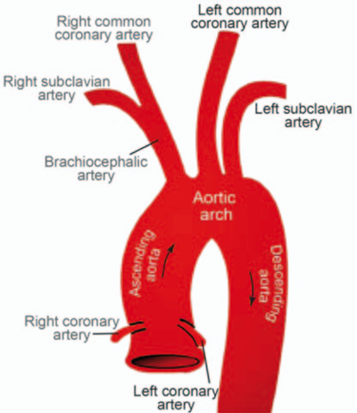



**2.2 Fluid Properties of Blood**

Blood is a composite fluid with plasma and cellular elements. Plasma is ~55% of blood by volume, while cells make up the remaining ~45% (the hematocrit, predominantly consisting of red blood cells (> 95% of the cellular volume) with a small amount of white blood cells and platelets (< 1% combined). Blood is denser and more viscous than water because of this particulate mixture (density ~1060 kg/m³; viscosity approximately 3 – 4 centipoise at 37 °C). The density and viscosity of blood predominantly dictate resistance to flow: according to Poiseuille’s law, resistance is directly proportional to the viscosity, therefore a higher hematocrit or lower temperature carrying blood, both of which would increase viscosity, also increases vascular resistance and cardiac workload. Blood’s multiphase composition means that it is a heterogeneous suspension, rather than a homogeneous solution, and as such, it does not follow the rules of Newtonian fluid. Rather blood acts as a non–Newtonian shear-thinning fluid, where red cells align with high shear rates (resulting in lower viscosity), while low sheer rates or stasis results in aggregation of cells (increasing viscosity).

Viscosity is the measurement of the internal friction of fluids (shear stress to shear rate ratio) and is influenced by three primary variables: composition, temperature and flow conditions (shear rate). In a vessel, at the center of the vessel is the greatest velocity of the laminar flow and it exhibits zero velocity at the wall, resulting in a velocity gradient (shear rate) across the radius (since at slow velocity flow the volume of blood is the same at a constant vessel diameter, so flow rate is only a function of the velocity). As the "apparent viscosity" of blood is effected by the shear rate, the red cells deform under high shear rates, shear rate, align and reduce viscosity (shear thinning), while at low shear rates near the wall or at slow flow rates cells aggregate (rouleaux) and increase viscosity. The "apparent viscosity" of blood is also decreased with decreasing vessel diameters (the Fahraeus-Lindqvist effect) causes the red cells to be pushed to the center of the vessel and a layer of cell-free plasma to form at the wall (minimum diameter is slightly greater than 40 um). The influence of different temperatures on viscosity is easily understood; warm blood has lower viscosity, and cold blood has increased viscosity. These slopes and variables all interact with each other to determine the final rheological behavior of blood and its flow resistance.

**2.3 Pathobiological Basis of Atherosclerosis**

**2.3.1 Introduction**

Atherosclerosis is a chronic arterial wall disease characterized by lipid-rich plaques (atheromas) forming in intima. It is the main cause of cardiovascular disease, including myocardial infarction, stroke, and peripheral artery disease, globally. It is a multifactorial disease due to environmental risk factors (hyperlipidemia, hypertension, smoking, diabetes mellitus) and genetic predisposition. Atherosclerosis is often present in early adulthood or even childhood and is usually asymptomatic during its progression, which can take years or even decades. Ultimately, existing atherosclerosis results in arterial narrowing, or reduced blood flow which causes significant morbidity and mortality worldwide. Because atherosclerosis may progress in silence, early detection and intervention for all risks is essential to prevent its serious complications.

**2.3.2 Role of Wall Shear Stress (WSS) on Arterial Health**

The first step is endothelial dysfunction; this is commonly initiated by hyperlipidemia, hypertension, diabetes, or smoking. The injured endothelium becomes more permeable and starts to express adhesion molecules which then recruit circulating monocytes. While the endothelium is injured, low-density lipoprotein (LDL) particles enter through a dysfunctional endothelium and accumulate in the subendothelial space. In the intima, the LDL is modified in some chemical fashion (e.g. through oxidation) which causes a local inflammatory response. Monocytes become attached to the endothelium, proceed to migrate into the intima, and differentiate to macrophages. The macrophages engulf oxidized LDL globules through scavenger receptors and transformed into lipid filled foam cells. The foam cells and lipid build up in the intima forms visible streaks of Lipid and foam cells, as such is referred to as a fatty streak, the earliest development of atherosclerotic injury.

The process progresses as smooth muscle cells migrate from the arterial media into the intima and proliferate there, a smooth muscle cell layer usually forms immediately on top of the lipid core with extracellular matrix material contributing over time to the build-up of a fibrous cap over the lipid core. T-lymphocytes and inflammatory cells consequently build up in the intima sustaining the inflammatory response. Development of the atherosclerotic plaque is characterized by a necrotic core of lipid and cellular debris surrounded by a fibrous cap of smooth muscle cells and collagen or connective tissue. The cellular events contribute to fatty streaks typically noted in autopsy that are evident in the arterial wall. Therefore, an atheroma can proceed, or progress, in a variety of different ways:

1. It can have a stable progression which happens in most cases.
2. It can have an abrupt progression leading to plaque rupture.
3. It can regress.

**2.3.3 Lesion in Atherosclerosis**

Atherosclerotic lesions are classified according to their morphology. The first lesions that are visible to the naked eye are called fatty streaks: these are flat or slightly elevated yellow patches on the intima of the arteries. Fatty streaks consist predominantly of foam cells (macrophages that have taken up lipids) and some isolated lipid deposits on the intima and they do not typically obstruct the lumen of the artery. If the fatty streak remains and lipid accumulation continues to occur, inflammation will occur, and the fatty streak will develop into a fibrous plaque (sometimes called atheroma). Fibrous plaques have more complex structures in that they have a necrotic core containing lipids and cell debris and they also have a fibrous cap comprising smooth muscle cells and collagen. The fibrous plaque protrudes into the vascular lumen, resulting in further narrowing of the artery.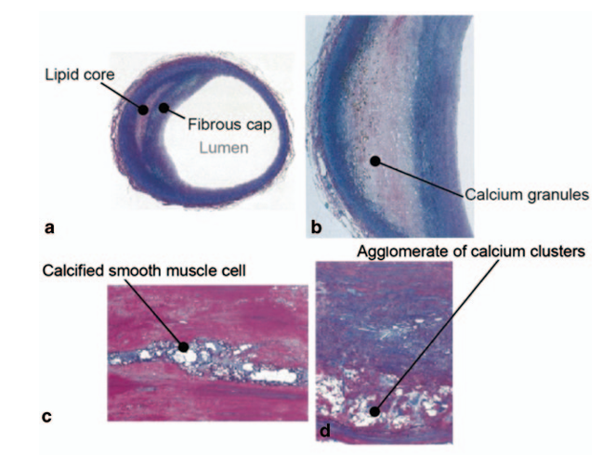

Complicated plaques are the most advanced type of lesion. In general, complicated plaques display areas of calcification, fibrous cap ulceration, and sometimes intraplaque hemorrhage or thrombosis. The fibrous cap may fissure or rupture and expose the necrotic core and allow clot formation. The transition from fatty streaks, which are simple lesions, to fibrous and complicated plaques with their more complex structures typifies the chronic nature of atherosclerosis and progression, a process that allows lesions that begin as isolated lipid deposits to become large obstructive plaques with irregular surfaces that lead to clinically relevant complications.

**2.3.4 Thrombosis in Atherosclerosis**

Atherosclerotic plaques rupture or the endothelial lining erode and expose the very thrombogenic core of the plaque and the subendothelial matrix to the bloodstream. Platelets adhere rapidly to the exposed elements through receptors for collagen and von Willebrand factor and become activated. The activated platelets then release granule contents and aggregating factors, which cause the adhesion of more platelets at the site of exposure, forming a primary platelet plug. Furthermore, the exposed tissue factor activates the coagulation cascade, producing thrombin from prothrombin, and converting fibrinogen to fibrin. So far, the combination of platelet aggregation and fibrin deposition has led to the formation of a thrombus on top of the exposed plaque tissue.

If the thrombus expands sufficiently to obstruct the artery, it will acutely diminish or sometimes completely Occlude blood flow. In the coronary circulation, the complete occlusion of a coronary artery produces a myocardial infarction; in the cerebral circulation, it produces an ischemic stroke. Even partial occlusion can produce unstable angina or transient ischemic attacks. The arterial thrombi that have formed on atherosclerotic plaques is mostly comprised of platelets (the so-called white thrombi), reflecting the rapid growth of thrombus on the damaged arterial wall. Overall, thrombosis at the site of the disrupted plaque is the immediate mechanistic inciting event contributing to acute ischemic vascular events.

**2.3.5 Stenosis of the Carotid Artery**

It is the narrowing of the carotid arteries and is most commonly caused by the accumulation of atherosclerotic plaques within the arterial wall. The carotid arteries are the primary arteries delivering oxygenated blood to the brain, thus it is essential that the arteries remain open for cerebral perfusion. Stenosis will decrease blood flow to the brain and increase the risk for ischemic stroke. Atherosclerotic plaques grow and over time occupy more luminal diameter, which increases the degree of narrowing and can create turbulent blood flow. Hemodynamic changes, such as low shear force in the vasculature downstream of the stenosis, can lead to additional plaque progression and plaque instability. Stenosis is generally asymptomatic until it becomes critical or experiencing a thromboembolic event. Critical stenosis may result in symptoms, such as transient ischemic attacks, which are defined as temporary neurological deficits. In clinical practice, stenosis severity is classified as the percent reduction in luminal diameter of the carotid artery, typically measured using imaging methods like Doppler ultrasound, CT angiography, and MR angiography. Treatment for patients with carotid artery stenosis varies depending on disability severity or symptomatic status from medical therapy to surgical therapy – either endarterectomy or stenting. Understanding the evolution of atherosclerosis within the carotid arteries is important when predicting an individual's stroke risk and determining an appropriate approach to therapy.

**2.3.6 Plaque Features**

1. Fibrous Cap Thickness: The fibrous cap is situated above the lipid core of the plaque and consists primarily of smooth muscle cells and collagen. An intact and thick fibrous cap provides mechanical strength and reduces the likelihood of plaque rupture. A thin or inflamed fibrous cap is mechanically unstable and is at risk for rupture, which predisposes to thrombus formation.
2. Lipid Core Size: The lipid core is made up of extracellular lipids, dead cell debris, and cholesterol crystals. A lipid core that is large, relative to the size of the plaque, is connected to more plaque vulnerability. Larger lipid pools can induce more stalls on the fibrous cap, making it more likely to rupture under hemodynamic forces.
3. Inflammatory Cell Infiltration: Macrophages, T-lymphocytes and other inflammatory cells inside the plaque degrade extracellular matrix components and weaken the fibrous cap by releasing proteolytic enzymes. The odds of a plaque rupturing increases as the inflammatory infiltrate increases (greater inflammation), irrespective of the presence of necrotic core lipids. Therefore, the chronic inflammatory process is an important determinant of plaque stability.

**2.4 Clinical Imaging**

Imaging is the first phase in the modelling of many cardiovascular diseases. This process can normally be broken into four steps:

i. Image acquisition

ii. Image segmentation

iii. Surface reconstruction

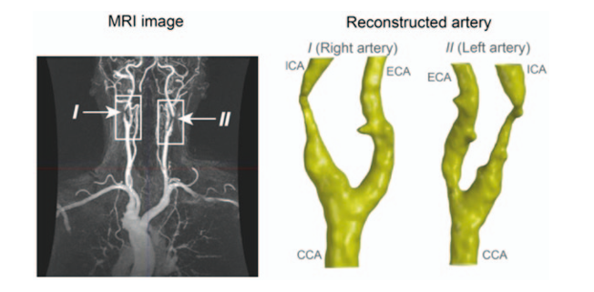

*Figure 3: MRI image & its reconstructed model [5a]*

During the image acquisition stage, imaging modalities (computed tomography (CT), magnetic resonance imaging (MRI), and ultrasound) present detailed anatomical and functional information for the vascular system. In the following image processing stage, the images will be segmented to identify and extract the regions of interest (ROI), for example, the lumen of the vessel and plaque structures. This next phase, surface reconstruction, describes the process of creating a three-dimensional representation of the segmented structures, retaining the geometry needed for computational analysis.

**2.4.1 Medical Image Acquisition**

In order to characterize the geometry of the cardiovascular system, a variety of medical imaging modalities are available. Two relevant imaging modalities in the study of carotid artery imaging are CT scans and MRI. While CT scans provide high-resolution images and are especially beneficial to visualize bone and bone structures, they do not have good soft tissue contrast to that of MRI imaging. Furthermore, CT scans use ionizing radiation and therefore have both cumulative risks from multiple exposures as well as exposure based on total life exposures, which are responsible for those risks. Therefore, the use of CT scans should be limited to applications where the benefits of imaging outweigh the potential harm rather than supporting a diagnosis limited to clinical signs and symptoms. MRI will provide for excellent soft tissue contrast and not have the ionizing radiation of CT scans, so MRI is a better candidate for this study. The added advantages of offering excellent depth of field using MRI would make the imaging of soft structures helpful, while supporting, if need be, a better image in color use and making use of an ultrasound. MRI scans rely on magnetic fields and radiowaves to acquire hypothetical cross-sectional images of specific sections of the body. A magnetic field is generated during a scan using the electric current induced in coils of wires. The hydrocarbons of the water molecules in the body are, when at rest, spinning aimlessly in three dimensions and then align to the field. A very short burst of tuned radio wave energy is sent through the center of the scanner which momentarily alters the quantum state of the hydrocarbon (e.g. flips the spin of the hydrocarbon). Once the radio wave stops being sent through the body, the hydrogen protons 'relax' and return to alignment, highlighting localized differences in tissue structure which create variations in contrast with one or more tissue parameter. Subject to subject anatomical and physiological differences will require different pulse sequences, to achieve the contrast desired. Images produced can take on a number of different formats, however, the most generic and widely used format is DICOM which contains the image data along with patient data.

**2.4.2 Image Segmentation**

Image segmentation is the process of dividing an electronic image into segments or regions, which helps streamline the analysis of particular regions in a more thoughtful focused manner. In medical imaging, segmentation is critical in differentiating tissues, organs, and abnormalities along with clinical diagnostic and therapeutic planning. Segmentation techniques classify pixels by group by pixel characteristics, which can include:

* Thresholding which segments based on a threshold value of intensity.
* Edge Detection which detects a boundary by identifying where an intensity value changes.
* Region Growing which takes a seed region and expands it by adding similar neighboring pixels.
* Machine Learning/Deep Learning, which utilizes trained models classify pixels with a high degree of accuracy.

Research into carotid arteries includes an active study of segmentation algorithms, and segmentation algorithms may be implemented in any programming language--C, C++, and Java are by no means an exhaustive list. Many commercially available or open-source medical software applications (Slicer, VXL, Fiji/ImageJ, ITK-SNAP, etc.) allow users to convert images, and segment, through graphical user interfaces. Post-segmentation, the 3D output files can be saved in CAD formats for analysis through computational fluid dynamics (CFD). The most appropriate output for CFD analysis has geometric and topological relationships defined so that they can be utilized in the CFD software as appropriate; however, having even more topological elements defined in the model as output may be useful.

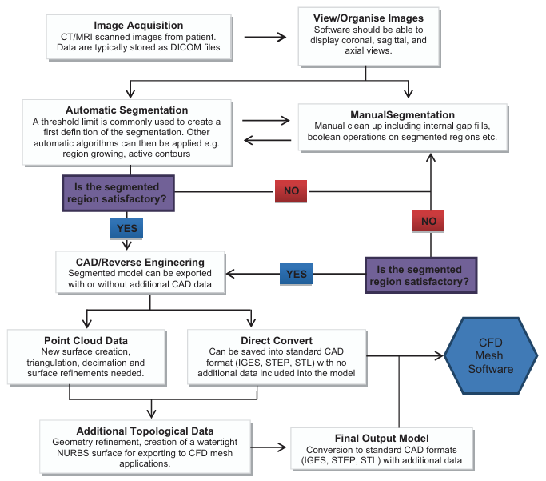

*Figure 4: Flow chart showing segmentation process [5a]*

**2.4.3 Surface Reconstruction**

After image segmentation, the next important stage of the modelling process is surface reconstruction. The segmentation process produces a 3D output file composed of the anatomical regions of interest. However, it is indeed possible that raw segmented data may not carry appropriate geometric and topological features required for computational fluid dynamics (CFD) meshing and may thus require some processing to provide the required data for further analysis. For example, the output sometimes consists of a wireframe model, meaning that there are no defined vertices, no defined edges, no defined surfaces, and no defined volume shells. These characteristics are important, as CFD solvers are based on forming complete, closed and well-defined geometries that can be used to simulate the flow and track changes in fluid dynamics for when certain parameters are altered.

To fill this gap, surface reconstruction is supposed to build a water-tight, topologically complete model from the segmented data. Water-tight simply implies that all edges connect properly, all surfaces are closed, and there are no stray points, overlaps, or gaps that could break the model as a whole. If this does not occur, the CFD software would fail to create a valid mesh or will produce incorrect results.

Surface reconstruction can occur in 2 ways - either the segmentation software directly exports to a compatible file format capable of meshing or topological information must be added to the file manually and/or semi-automatically. Some advanced segmentation platforms will allow direct export to a meshing platform, in other cases, the user is responsible for surface repairs and improvements. One of the improvements required during reconstruction is to provide proper face connectivity. Proper face connectivity means that every point and line on the surface logically connects to adjacent surfaces, allowing for construction of volume meshes, which is required for fluid flow simulations.

One notable difficulty encountered at this stage is that of generating "dirty" CAD geometries. Dirty geometries are exported models that have defects such as non-intersecting lines, overlapping surfaces, stray points, slivers, and gaps. There are several potential sources for dirty geometries, i.e non-issues during the segmentation process, dissimilarity of file formats, or incompetencies of the imaging data itself. If dirty geometries are not corrected, a number of significant issues can occur during meshing and subsequent simulations. Mesh generation may fail altogether or generate elements that are of poor quality, which can result in convergence issues during certain simulations. 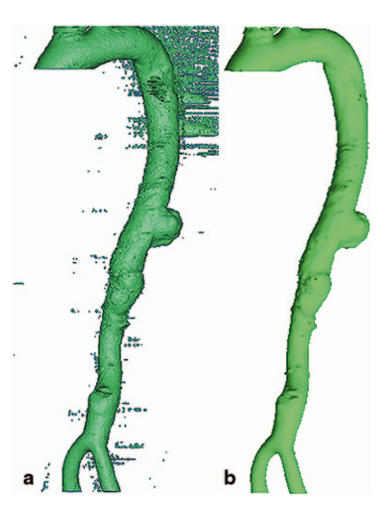

In order to fix dirty geometries, many different repair methods exist. They can range from manual clean-up with CAD specific software to automatic repair methods offered in meshing environments. General operating steps often include healing gaps, trimming intersecting surfaces, deleting duplicate points, and confirming that surfaces make up closed volumes. Some CFD meshing software packages include built-in automatic cleaning tools while more problematic instances may not be fixable and need to be exported to stand-alone CAD repair software outside of the meshing environment.

Above all, surface reconstruction guarantees that the 3D model accurately represents the anatomical structure while preserving the geometric definitions. A valuable reconstruction process is critical to obtaining a robust mesh able to precisely parameterize the hemodynamic simulation in addition to accurately modeling blood flow in stenosed arteries.

**2.5 Fluid Dynamics**

**2.5.1 Rheological Models of Blood Flow**

Rheology is a science that, in the medical context, studies the flow and deformation of matter. Blood is not a simple liquid and is sent throughout the body via different types of blood vessels in a complex way. Blood carries quite a high shear rate in arteries such as our aorta and healthy Carotid artery because it is relatively fast flowing through a large diameter artery. The viscosity of blood is about constant, so it is ok to think of blood as Newtonian fluid. This simplification allows for making blood flow easier and quicker to simulate. The situation gets much more complicated when you examine smaller vessels or pathological conditions such as stenosis when blood vessels narrow down. In these cases, blood will behave like a non-Newtonian fluid, meaning blood's viscosity will change as a function of its flow rate. This complexity will bring model increases, but also increases the model's accuracy of properties [5], [6], [7].

In order to explain the differences in blood behavior, scientists use various mathematical models. The Power Law, Carreau-Yasuda, Casson, Herschel-Bulkley, and others that we have examined, all attempt to better understand the flow of blood under numerous conditions, both in normal circulation and when plaque interrupts flow. As a common example in literature, we will describe shear stress (τ) as an example of the Power-Law model:

**τ = mγ˙n**

In this equation “n” and “m” show the fluid's consistency and the degree of non-Newtonian behavior, respectively.

**η = mγ˙n−1**

The viscosity (η) decreases when shear rate increases for the shear thickening fluids (n > 1) or increases for the shear thinning fluids (n < 1). Nevertheless, this model has limitations, particularly at extreme low or high shear rate conditions, which can result in incorrect predictions for viscosity [8], [9].

**Table I. Viscosity Models** [10]

| | **Viscosity Model Type** | | --- | | | **Parameters** | | --- | |
| --- | --- | --- | --- |
| Power Law  μ=0.0035Pa. s | k = 0.0035  n = 0.6 |
| Newtonian | μ = 0.0035Pa. s |
| Casson | τ0 ​= 0.004Pa  μ0 ​= 0.022Pa  m = 100 |
| Carreau-Yasuda | μ0​ = 0.022Pa  μ∞ ​= 0.002Pa  λ = 0.11s  n = 0.392  a = 2 |

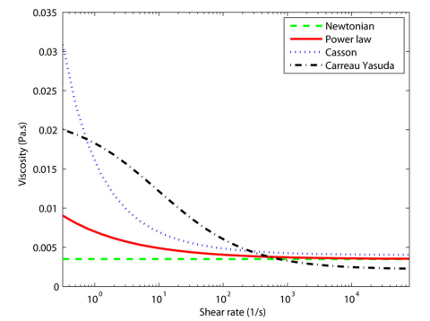

**2.5.2 Role of Navier Stokes Equation in Blood Flow Simulations**

The Navier-Stokes equations (NSEs) are instrumental in modeling blood flow as they can model the motion of a viscous fluid. The NSEs take into account velocity, pressure, and viscosity. The NSEs will show the effects of flow disturbances due to narrowing of the artery between the incoming blood and the distal artery. When interpreting the NSEs, we will see, in detail, the displacement of flow patterns such as: the development of a vortex, an area of slower blood movement, etc. Disturbed flows are also areas likely to have plaque buildup or where it is likely to damage the artery. Navier-Stokes equations mathematically model the flow of blood. We can express conservation of momentum and mass for a 3-D incompressible fluid such as:

Equation 1: incompressible flow (Continuity Equation):

**∇⋅v=0**

Equation 2: Conservation of Momentum equation:

**ρ($\frac{∂v }{∂t}$ +v⋅∇v)=∇⋅σ + f**

Where:

* ρ represents density, which is constant,
* v represents the velocity vector,
* σ represents the stress tensor,
* f represents the external or body force (assumed zero in the simulations).

Equation 3: The stress tensor can be decomposed into deviatoric and hydrostatic stresses:

**σ = −pI + τ**

Where:

* p represents the pressure,
* I represent the identity tensor,
* τ represents the deviatoric stress tensor, which is a function of the shear rate tensor D.

Equation 4: The deviatoric stress is given by:

**τ=μ γ˙(D)**

Where:

* μ represents the dynamic blood viscosity,
* γ˙​ represents the shear rate.

In addition, the shear rate tensor D is defined as:

**D= 12(∇v+∇vT)**

Finally, the shear rate γ˙ is defined by a function of D:

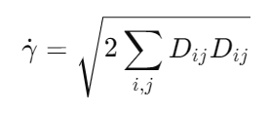

**2.5.3 Boundary Conditions for Inlet and Outlet in Arterial Models**

The accuracy of boundary conditions is essential when implementing simulations. The blood entering the artery from the heart follows a pulsing pattern which needs to be accurately modeled in the simulation. The outlet also needs to model the flow of blood exiting the artery and into smaller blood vessels [5], [10].

The variable flow, as indicated in Fig. 1, has a flow velocity that changes with time. In this study, the flow rate ‘Q’ (time-dependent) is used to determine inflow velocity. This is referenced on Holdsworth et al's study model. For the heart rate of 60 beats per minute (bpm) This configuration has a wave form duration of T = 1.0 [s]. The diastolic phase is from 0.47 till 1.0 seconds and the systolic phase is from 0 till 0.47 seconds [11], [12].

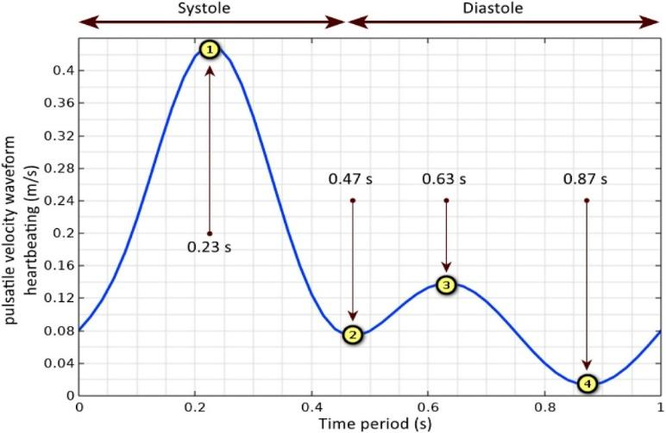

For a viscosity of μ = 0.004 Pa s (Table I), the model assumes that blood is incompressible, homogeneous, and has a density of ρ = 1060 g/cm3. For achieving realistic blood flow dynamics in the arterial system, these properties are required [11].

| **Parameters** | **Value** | **Unit** |
| --- | --- | --- |
| Blood density | 1060 | Kg.m−3 |
| Blood viscosity | 0.004 | Pa s |
| Artery diameter | 11 | mm |
| Artery length | 200 | mm |
| Max. Inlet velocity | 43 | cm.s−1 |
| Min. Inlet velocity | 1.5 | cm.s−1 |
| Max. Re number | 1253 | - |
| Min. Re number | 43.7 | - |
| Womersley Number | 7.10 | - |

**Table II. CFD Parameters** [11]

A key factor in this model is the Womersley coefficient which is given by

α=r $\sqrt{\frac{ω}{v}}$

the kinematic viscosity of blood is given by ω while ν is, The angular frequency of the driving pulse. The Womersley index for blood circulation has been reported as 7.10, by Caro et al [13]. The Womersley index is a dimensionless number for characterizing pulsatile flow according to flow conditions and geometry of the system.

Physical properties of blood as a Newtonian fluid: The blood plasma is mostly proteins, hormones, glucose and water (91% by volume), and contains properties of a Newtonian fluid (standard values between 1.1 and 1.3 (megapascal)) at (37 C) which is the human body temperature.

**2.6 Fluid-Structure Interaction (FSI) Modeling in Blood Flow Analysis**

Simulating the blood flowing through the arterial system requires a very precise visualization of the relationship between human blood (fluid) and the human arteries (solid). Pure fluid dynamic (CFD) simulations frequently model vessel walls as rigid, which ignores the complex biomechanical environment of living tissue and, as such, is a simplification. Fluid Structure Interaction (FSI) techniques allow fluid flow - using CFD - to dynamically couple with the solid structure - using the principles of elasticity for a biomechanical environment [14][15]. This enables the transfer of momentum and physical information back and forth between flow field and structure, to represent the same flow that exists in vivo. FSI enables the ability to obtain more physiologically meaningful values for critical flow parameters such as velocity profiles, pressure as well as wall shear stress (WSS). FSI brings computational estimates closer to clinical reality, providing more confidence in clinical application (i.e. diagnostic, or predictive modeling) [16].

**2.6.1 Fluid Domain Setup**

Blood is modeled as a non-Newtonian fluid with a density of 1060 kg/m³, which corresponds to physiologically normal values. The non-Newtonian behavior is captured with the Carreau Yasuda model, which accurately reflects blood's shear-thinning behavior. In the fluid region, the incompressible Navier-Stokes equations control the flow as:

∇ · u = 0

ρ (∂u/∂t + u · ∇u) = -∇p + ∇ · τ

where:  
- u is the velocity vector,  
- p is the pressure,  
- τ is the extra stress tensor,  
- ρ is the blood density.

Boundary conditions:

At the inlet, we implemented a user-defined function (UDF) that applies a pulsatile velocity profile taking place between 0.2 m/s and 0.5 m/s to account for the differences in the pulsatile flow of the cardiac cycle. The outlet was held at a constant atmospheric pressure (gauge pressure = 0 Pa). All walls were hold as no-slip where the fluid velocity at the arterial wall will be the same as the velocity of the moving arterial wall [17].

**2.6.2 Solid Domain Setup**

The Human carotid artery (Tissue) is assumed to behave as a hyperelastic Mooney-Rivlin material and will capture the elastic behavior of vascular tissues in the physiological loading condition.

Some Material Properties:

- Density: 1450 kg/m³

- Bulk Modulus: 0.3 MPa

- Poisson's Ratio: 0.49

- Mooney-Rivlin coefficients were c10 = 0.085 MPa, c01 = 0.045 MPa

- Incompressibility factor D1 = 6.67 × 10⁻⁶

Structural Mechanics can follow the momentum equation:

ρs (∂²d/∂t²) = ∇ · σs + fs

where d is the displacement vector, σs is the solid stress tensor, and fs are body forces. The hyperelastic behavior is given as:

W = c10 (I1 - 3) + c01 (I2 - 3)

Where I1 and I2 are the first and second invariants of the right Cauchy-Green deformation tensor [17].

## **2.6.3 FSI Coupling Strategy in ANSYS Workbench**

The coupling between the fluid (ANSYS Fluent) and solid (ANSYS Transient Structural) solvers in the ANSYS Workbench environment has a strong coupling that allows independent calculations of the blood and arterial walls at every time step with dynamic equilibrium at the fluid-solid interface.

The FSI interface enforces the following two primary physical conditions:

1. Kinematic Condition (Continuity of Velocity):

u_f = ∂d_s/∂t

the fluid velocity matches the wall velocity and no-slip in the deforming mesh holds.

1. Dynamic Condition :  
    σ_f · n = σ_s · n

This guarantees that the traction that the fluid applies to the wall is or is not balanced by the structural stress response.

In each coupling iteration, the fluid solver calculates, first, the pressure and shear which the wall experiences at the wall, these shear and pressure loads are transferred to the solid solver as boundary loads. The solid solver then solves for deformation, and returns the wall displacement back to the fluid solver which updates mesh dynamically with smoothing and remeshing algorithms. This formulation precisely captures the real-time interaction between blood flow and vessel deformation.

Both the fluid and solid regions were meshed with tetrahedral elements having a size of 0.4 mm, with inflation layers to resolve the near-wall gradients. A sphere of influence was also added around the carotid bifurcation (CCA junction) to refine the mesh in areas with complicated fluid flow [18][19].

**2.6.4 Impact of FSI on Predicted Hemodynamic Parameters**

Using FSI is a major improvement from simulating using the rigid-wall CFD method, because there are more realistic flow velocity profiles inside the artery that evolve during the arterial wall deformation. In summary, these velocity profiles represent how the velocity profiles normally look under physiological conditions – such as flattened centerline velocities during systole, spindled centerline velocities during hub or shear, and smooth parabolic profiles during diastole. This is due to the compliant walls which yield to accommodate the pulsations flowing into them, a behavior which does not exist in dynamic simulation based on rigid walls.

Likewise significant differences exist in the pressure waveforms in FSI. The vessel wall being allowed to deform with the pressure pulses dampened peak pressures and caused shifts in the waveform shape as well as phase shifts of the pressure gradient. This behavior is like what is seen clinically with catheter-based pressure measurements. All these effects are not happening in rigid wall boundaries and thus will lead to pressure gradients which are incorrect and therefore give misleading predictions which are required to diagnose conditions such as stenosis.

The prediction of wall shear stress (WSS) is also significantly improved with FSI. The deformation of the arterial wall changes the near-wall flow characteristics, which produce patterns of WSS that vary temporally and spatially. These WSS patterns are important for better interpreting endothelial cell responses and to understand disease progression, such as atherosclerosis. Rigid models of WSS prediction tend to over-predict average WSS during systole and under-predict average WSS during diastoles which miss these key oscillatory behaviors of WSS.

Overall, FSI contributes depth to the predictive ability of blood flow models by insightfully accounting for the true dynamic interaction between blood and vessel wall mechanics. Full fluid mechanic models represent some of the most accurate and dynamic hemodynamic assessments and have the potential to provide researchers and clinicians with an excellent means of simulating hemodynamic environments for studying disease progression, device testing, and surgical planning [20].

**CHAPTER 3**

**DESIGN METHODOLOGY**

**3.1 CAD Geometry and Stenosis Growth**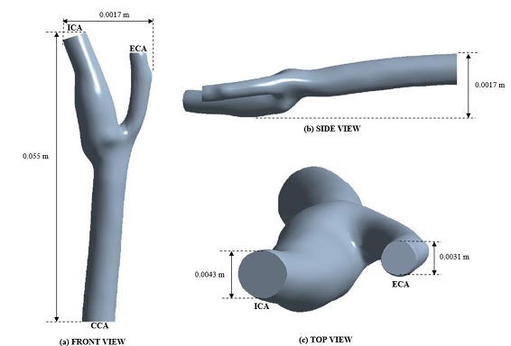

Due to the significant geometric variability observed in patient-specific data across different sources, the project team opted to acquire a standardized, realistic model of the carotid artery, incorporating the bifurcation as well as the internal and external carotid branches. To this end, a suitable model was sourced from an online repository (Grab-CAD) and subsequently validated, confirming its development by the prestigious Cornell University. The key geometric parameters of the selected model are summarized in the table below.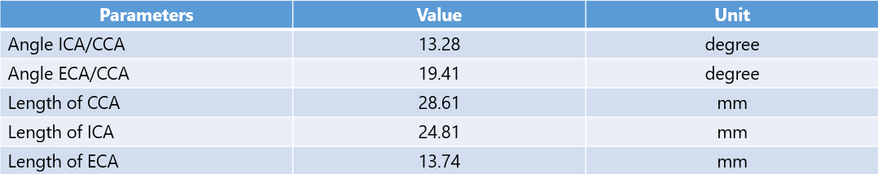

*Figure 9: Geometric Parameters of the Artery*

The selection of this model was based on its anatomical realism and its dimensional consistency with the average range of arterial diameters reported in a study involving 400 patients. [21]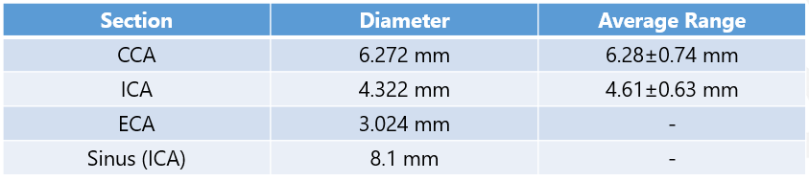

*Figure 10: Average ranges of CCA & ICA Diameters [21]*

For the simulation of stenosis development, plaque growth was modeled on the internal carotid artery (ICA). The decision to localize plaque formation within the ICA was supported by findings from widely cited research, which demonstrated a higher prevalence of plaque deposition in this region [22]. To maintain simplicity in the model, symmetry was established as a design objective, and the diameter of the ICA was locally reduced from both sides. The resulting stenosis is characterized as asymmetric and eccentric, leading to significant flow disturbances and the formation of vortices. Diameter reductions were implemented in three progressive stages corresponding to 25%, 50%, and 75% narrowing.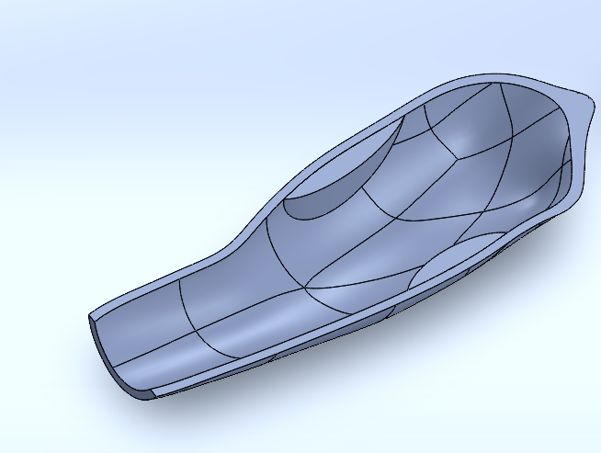

*Figure 12: Internal view of 25% stenosis*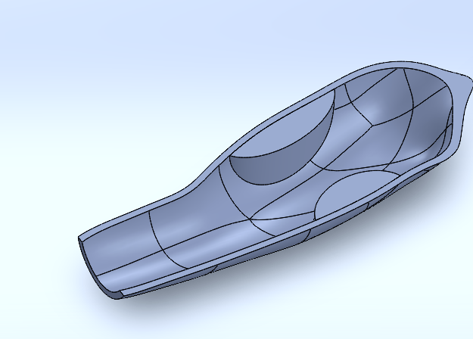

**3.2 Computational Fluid Dynamic and Mesh Setup**

* + 1. **Concept Development**

We initiated our project by establishing a solid numerical CFD foundation and introducing FSI complexities gradually. We arranged this into 4 subsequent steps:

1. Blood Flow Modeling
2. Transient Pulsatile & Non-Newtonian Setup
3. Material Properties & Arterial Deformation
4. Meshing

**i. Blood Flow Modeling**

We first treated blood as an incompressible, Newtonian fluid, governed by the continuity and Navier–Stokes equations [10]:

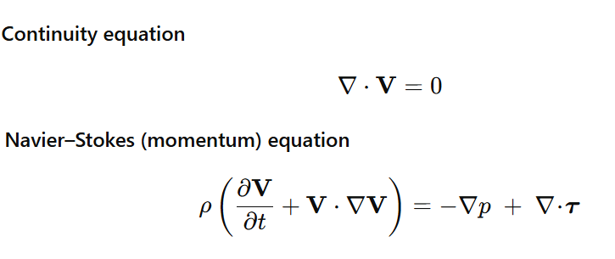

Here, we assumed ρ = 1060 kg/m³ and µ = 3.5×10⁻³ Pa·s, average values when the diameter of the cylinder (≈5–6 mm) was large enough that the fluid viscosity was constant in [23][24]. A constant fully developed parabolic inlet velocity 0.315 m/s, and zero-gauge pressure at the outlets were specified [25]. This simple laminar model enabled us to investigate mesh quality, boundary conditions, and the stability of the solver.

**ii. Transient Pulsatile & Non-Newtonian Setup**

Next, we "woke up" the model with transient conditions to correspond with a time step of 0.01 s, and 60-bpm cardiac cycle (T = 1 s). The outlet pressure was updated to physiological 13 332 Pa. Finally, to model blood's shear thinning behaviour, we implemented the Carreau–Yasuda viscosity law.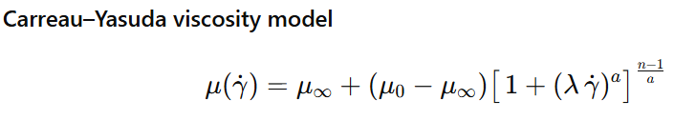

where μ₀ = 0.056 Pa·s, μ∞ = 0.0345 Pa·s, λ = 8.2 s, a = 1.23, and n = 0.3568. This non-Newtonian step helped us see how shear rates in the stenosis throat alter viscosity in real time.

**iii. Material Properties & Arterial Deformation**

In order to progress toward a two-way FSI, instead of treating artery wall as rigid solid, we modelled it as a simple linear elastic solid deforming under fluid pressure using the momentum equation for solids:

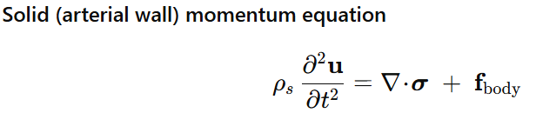

and an isotropic stress–strain law:

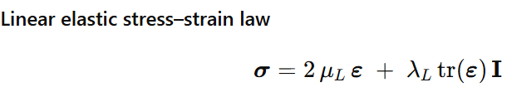

where Lamé parameters λ_L and µ_L come from the Poisson’s ratio (ν) and elastic modulus (E) through:

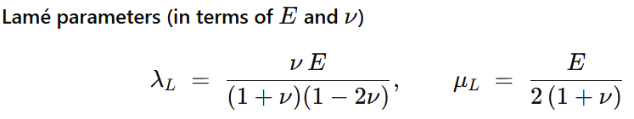

We used ρₛ = 1120 kg/m³, ν = 0.45, and E = 1.106×10⁶ Pa for a healthy artery [10]. Our CAD model added a uniform 1 mm wall thickness around the fluid geometry.

**iv. Meshing**  
In the beginning of the meshing, the carotid artery geometry pattern was discretised as a three-dimensional tetrahedral mesh. Fluid domain was comprised of 863 223 tetrahedral elements on 5 boundary-layer inflation layers, while the arterial wall (solid domain) was represented by 145 635 tetrahedral elements. This created a combined mesh of 1 012 983 for CFD analysis [10]. Mesh quality was measured via skewness. The highest skewness was 0.89, the average skewness was 0.22, and it produced an acceptable mesh quality with a number of quintets that were slightly distorted [11].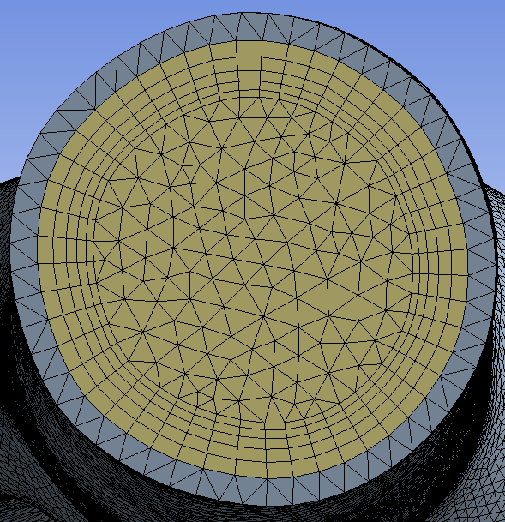

A grid-independence study defined three meshes with cell sizes of 0.35 mm, 0.40 mm, and 0.50 mm [10]. The cell size of 0.40 mm was deemed most representative of grid criteria since velocity showed no variation of more than 1% from the finer 0.35 mm mesh, but larger than 0.50 mm cell sizes were higher than the previous cell sizes. A growth of 23% in number of elements (1 012 983 to 1 532 433) increased run time by 220% while peak velocity variation increased to 2.449%, which suggests a reasonable balance in accuracy and computational cost, for the choosing the 0.4mm element size.

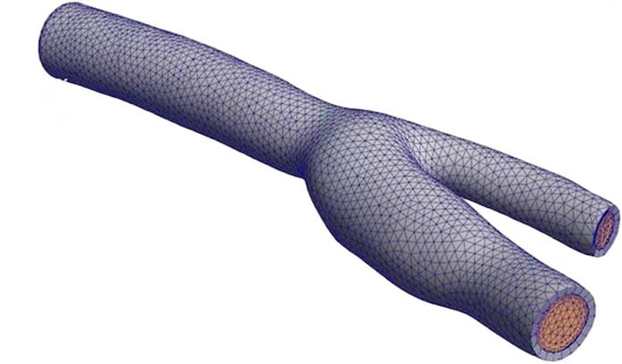

Time-step independence was similarly evaluated using an unsteady simulation for a 0.5s sinusoidal cycle. Time steps of 0.005 s, 0.01 s, and 0.02 s (with 50 iterations for each time step) were considered, and the 0.01 s time step produced changes in velocity for two mesh relationships that were all within the acceptable range of variation, thus confirming transient stability without undue computational costs.

At the end of these initial steps, we had:

* A validated Newtonian, laminar CFD baseline
* Turbulence model insight (SST chosen)
* Transient, non-Newtonian pulsatile runs
  + 1. **Concept Finalization**

This stage included mesh creation based on convergence, scripting boundary conditions, solver setup, two-way FSI, and varying stenosis and stiffness parametrically. We automated and validated each step against established best practices for guaranteed accuracy and efficiency of carotid artery CFD/FSI analysis.

**i. Advanced Mesh Generation**

To begin, we used the Patch-Conforming process, a bottom-up approach that grows elements from edges and faces while strictly respecting all geometric boundaries [26]. Although the boundary meshes produced are superior, the process cannot handle small imperfections in CAD, and it increases setup time tremendously using patient-specific geometries.

In contrast, the Patch Independent method used a top-down Delaunay approach in that we fill the volume first and then project to faces, which allows us to ignore irrelevant model features and deal with poor-quality CAD [27]. Important benefits include:

1. Geometric Robustness: Patch Independent has good tolerance to small gaps or slivers in STL or CAD imports and needs no manual defeaturing.
2. Speed: As a result of not having to conjoin every mesh patch up front, mesh generation times decreased by ~30% in our tests, leading to faster iteration on mesh controls [28].

Additionally, we introduced a sphere of influence in the bifurcation region to capture the results in that area more accurately. The sphere of influence reduced the element size to 0.2mm (half of what we were using in other regions). As mentioned previously, after a grid convergence index (GCI) study of 0.35, 0.40 and 0.50 mm meshes, a global cell size of 0.40 mm was used since it yielded a maximum of ≤ 1% difference on the Wall shear stress (WSS) from the 0.35 mm finest mesh but estimated a reduced computational time of ~23% [10]. In addition, prism inflation layers (5 layers) captured the near-wall velocity gradients [29]. 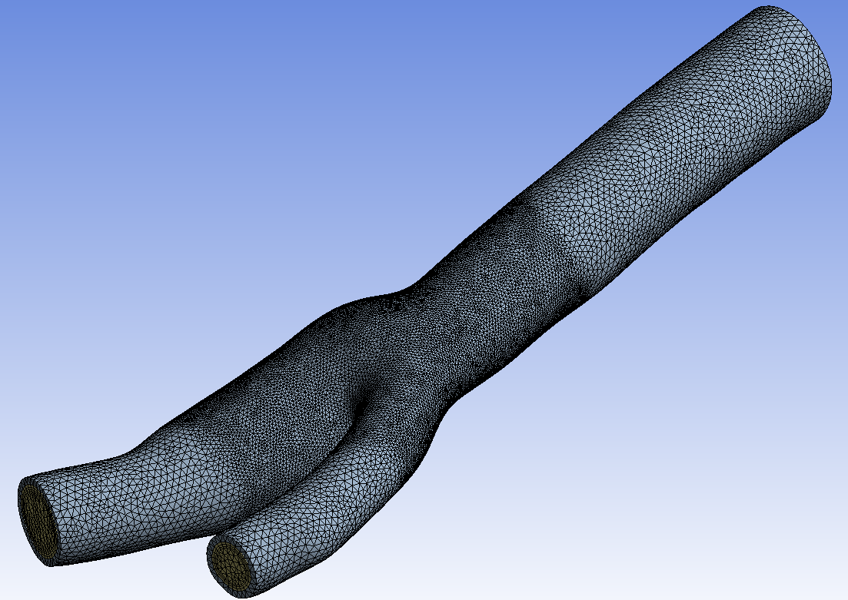

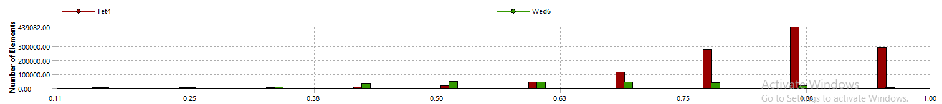

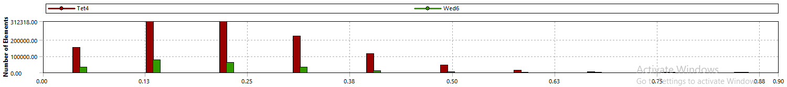

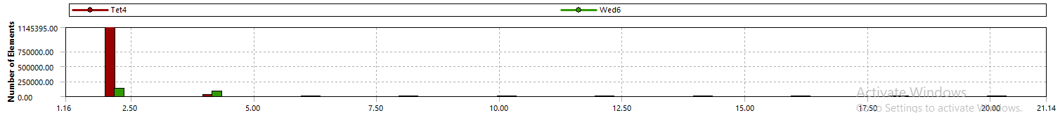

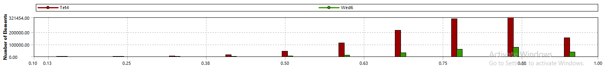

*Figure 17: a) Element Quality, b) Skewness, c) Aspect Ratio, d) Orthogonal Quality*

Mesh quality metrics of maximum skewness < 0.9, average skewness of ~ 0.22, orthogonality > 0.25, aspect ratio < 10 were tracked automatically to prevent solver instabilities.

**ii. Boundary and Initial Conditions**

We used UDFs to define pulsatile outlet and inlet conditions. The inlet condition was a parabolic velocity (fully formed) waveform (0.315 m/s peak at t = 0.21 s) that mimicked a 60-bpm cycle; [30] and outlet pressures also followed a shifted waveform peaking of 12 kPa at t = 0.45 s. For inlet and outlet boundary conditions, walls were fixed, and other wall boundaries were allowed unconstrained deformation [10].

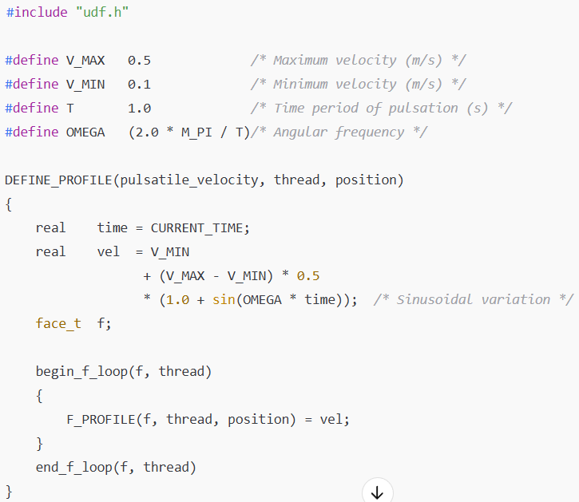

Inlet Velocity UDF

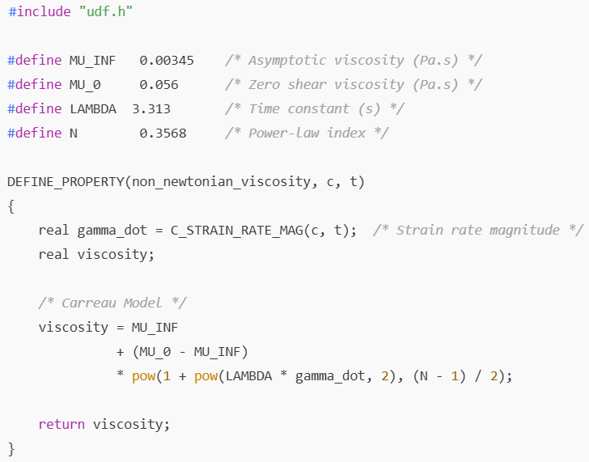

Carreau model UDF

**iii. Fluid–Solid Interaction**

We used the Arbitrary Lagrangian–Eulerian (ALE) method for FSI, coupling Fluent with a hyper‐elastic solid solver. Structural mechanics employed ρₛ = 1450 kg/m³, ν = 0.49, Bulk Modulus k = 0.3 MPa for healthy walls. Interface conditions enforced continuity of displacements and equilibrium of tractions [10].

**CHAPTER 4**

**Results**

**4.1 Mesh Independence Study**

The table presents our mesh independence study with three element sizes (0.50 mm, 0.40 mm, 0.35 mm) that included mesh size, solver iterations, maximum velocity prediction, benchmark velocity, and percent error.

**Table III. Mesh Independence Study**

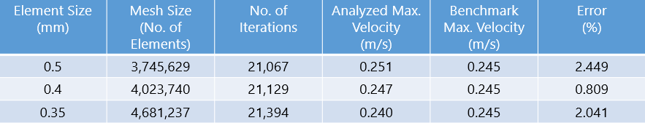

* 0.50 mm mesh: This initial mesh case with 3.75 million elements used 21,067 iterations before the solution converged. This simulation gave a maximum velocity prediction of 0.239 m/s; which was a184 under prediction by 2.45% relative to the known solution velocity of 0.245 m/s. The results would suggest that this coarse mesh probably did not resolve high gradient flow phenomena sufficiently, especially in areas of high curvature (as in the stenosis throat) for the geometry, which limited the accuracy of localized velocity predictions.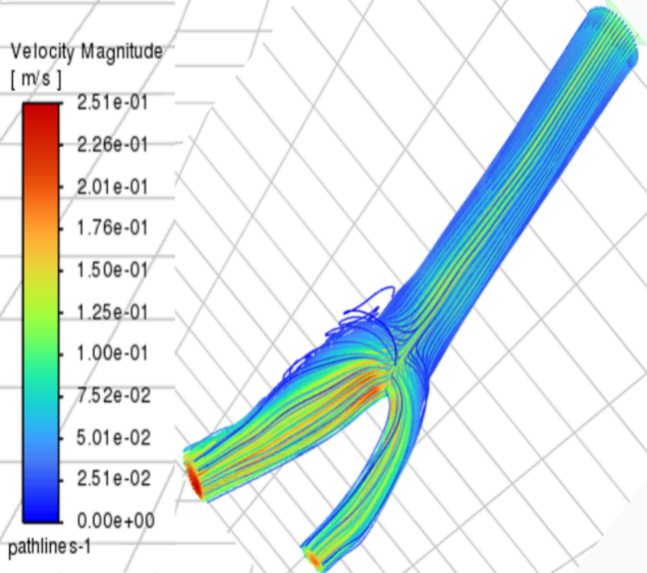
* **0.35 mm mesh:** By refining the model to 4.68 M elements and performing 21 394 iterations there was a small relative improvement to spatial resolution, but the maximum velocity prediction was just 0.240 m/s and the error was 2.04% indicating successful variable fine scale refinement by introducing skewness and stiffness leading to diminishing returns. 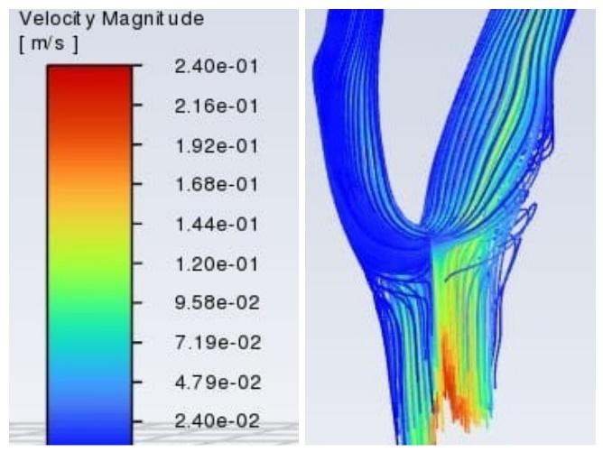
* **0.40 mm mesh:** This mesh lies in between and produced 4.02 M elements and underwent 21 129 iterations and reached a maximum velocity of 0.247 m/s which was only 0.81% greater than the benchmark [31]. Overall, this mesh produced a reasonable level of accuracy, and a moderate amount of computational expense. The total number of iterations also only went up by 0.1% over the 0.50 mm case, indicating a net gain by the solver at this grid resolution. 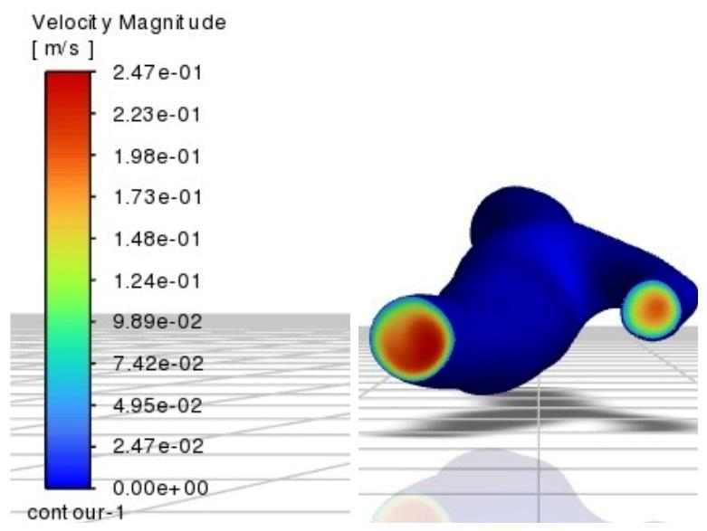

According to grid‐convergence‐index principles, the optimal mesh minimizes both solution error and runtime growth; here, the 0.40 mm mesh clearly satisfies that criterion and was adopted for all subsequent CFD and FSI analyses. 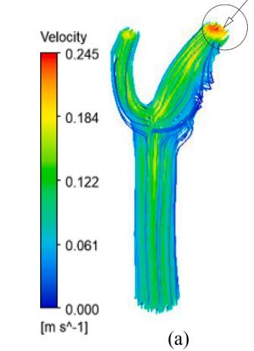

**4.2 CFD Results for Healthy Carotid Artery (Benchmarked)**

a) Velocity

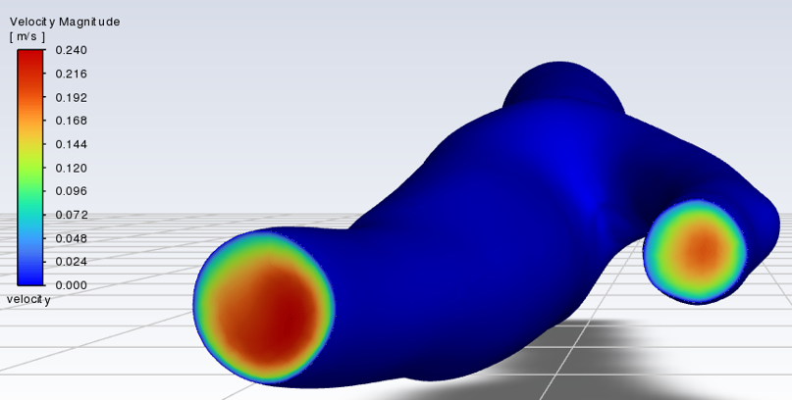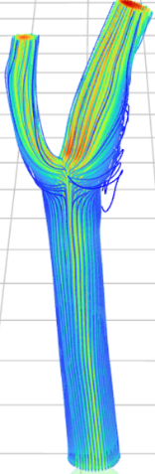

*Figure 22 Shows the Velocity Magnitude and Streamlines for the Healthy Carotid Artery*

Figure 22 shows the instantaneous magnitude of velocity in a patient-specific carotid artery bifurcation at peak systole with a colour map to represent low-velocity aera (0 m/s—deep blue) and high-velocity area (0.24 m/s—bright red). At the common carotid inlet, the flow exhibits the theoretical parabolic laminar profile—where the centerline velocity is approximately 2x the average and then decays to zero at the wall due to the no-slip condition [32]. As the fluid nears the bifurcation, it bifurcates to the internal and external branches, while approximately retaining the inner parabolic structure, consistent with the CFD–4D flow MRI comparisons of velocity magnitudes at the bifurcation plane that included perpendicularly intersecting branches [33]. Both outlets show residual parabolic topologies despite curvature, confirming laminar flow. Note the smooth gradient transitions demonstrate the high-quality mesh (0.40 mm global cell size with prism layers), which is sufficient to resolve the boundary-layer gradients with no numerical artifacts.

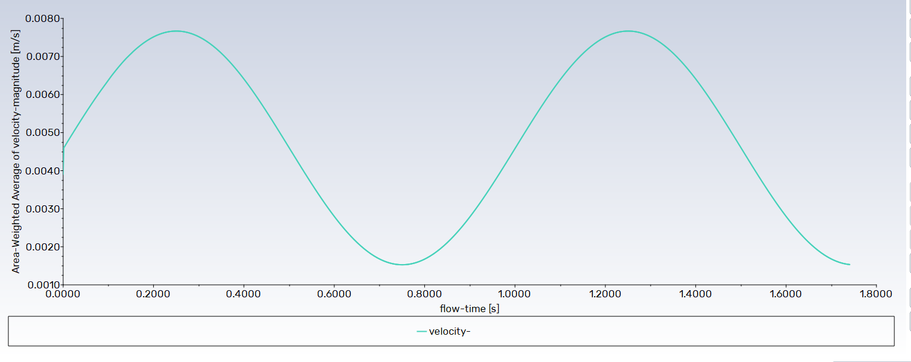

*Figure 23 Shows the Area-Weighted Average of velocity magnitude against flow-time graph*

The provided graph illustrates the area-weighted average of velocity magnitude over time for a healthy carotid artery, demonstrating the inherently pulsatile nature of blood flow within this vessel. The graph displays cyclical variations in velocity magnitude over a period of approximately 1 second, consistent with a typical cardiac cycle [10]. The systolic phase is characterized by a rapid increase to a peak velocity, reaching approximately 0.75 m/s at around 0.25 s and again at 1.25 s. Following systole, the velocity undergoes a deceleration during the diastolic phase, reaching a minimum value of approximately 0.15 m/s around 0.8 s. The presence of non-zero velocity during diastole indicates continuous forward flow throughout the cardiac cycle, which is characteristic of the healthy internal carotid artery flow pattern that supplies the brain [35]. This pulsatile velocity profile, with distinct systolic peaks and diastolic flow, is representative of the normal hemodynamic environment in a healthy carotid artery.

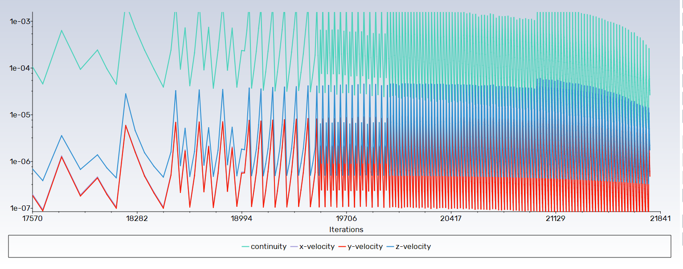

*Figure 24 Shows the scale residuals obtained for the Healthy Carotid Artery*

The provided graph illustrates the convergence history of the Computational Fluid Dynamics simulation for the healthy carotid artery model, depicting the scaled residuals for continuity and the three velocity components (x-velocity, y-velocity, and z-velocity) as a function of the number of iterations. Numerically analyzing the graph, the residuals for all variables exhibit a cyclical, oscillating pattern over the displayed range of iterations (approximately 17570 to 21841). The residuals for the velocity components oscillate between approximately 10 − 7 and 10 − 5, while the continuity residual oscillates at a higher magnitude, between approximately 10 − 4 and 10 − 3. The residuals for the velocity components are observed to be below the 10 − 5 threshold, which is often considered a sufficient criterion for convergence in transient CFD simulations and aligns with the convergence tolerance specified in related studies. The oscillating behavior is characteristic of iterative solvers applied to transient flow problems. The observed trends suggest that the simulation has reached a state where the solution is iteratively converging within each time step, contributing to a numerically stable result for the flow field in the healthy carotid artery.

b) Wall Shear Stress (WSS)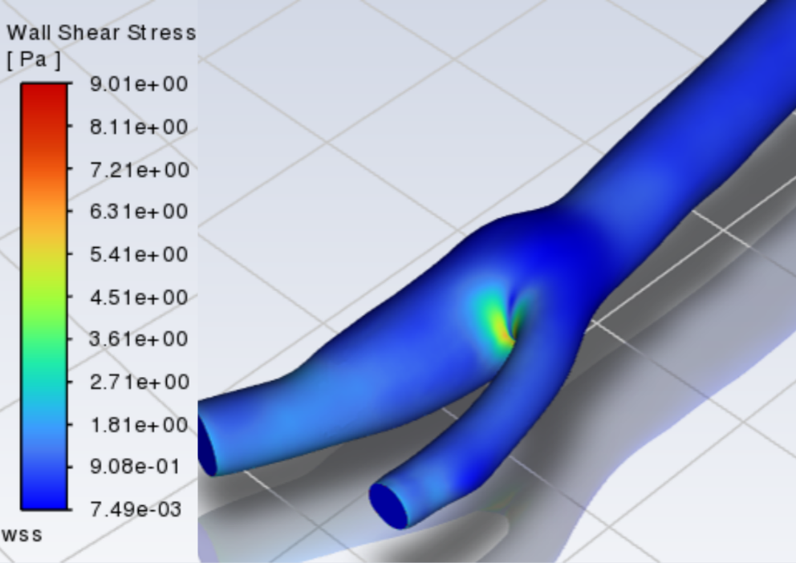

*Figure 25 Shows the Wall Shear Stress Distribution along the Healthy Carotid Artery*

The WSS magnitudes shown in Figure 25 relate to established hemodynamic data: in straight arteries time-averaged WSS is typically between 1 and 7 Pa [35] and a "baseline" of 1.5-2.5 Pa is frequently reported [36]; disturbed, recirculating flow regions, such as the carotid sinus, have values well below that range, from ±0.4 Pa or 0-1 Pa [35], matching the deep-blue (<1 Pa) regions at the bulb; the bright yellow-green hotspot (≈ 6-9 Pa) which is at the inner apex, is associated with accelerated flow splitting, which can exceed 7 Pa in vivo, and is associated with increased shear stress [4]; the literature has also confirmed that WSS in excess of 7 Pa begins to stress endothelial cells toward erosion or thrombosis [37], whereas values below 1 Pa indicate atherogenic processes [38]; experimental ultrasound studies indicate 1.0-1.6 Pa on the outer ICA wall under normal flow conditions [39], and computational models consistently place low-shear pockets at bifurcation bulbs in the 0.1-0.6 Pa range [40]; therefore, the simulated values of 7.49 × 10⁻³ - 9.01 Pa directly corresponds with the literature-reported values on flaccid for straight, high shear and recirculation regions.

c) Pressure Distribution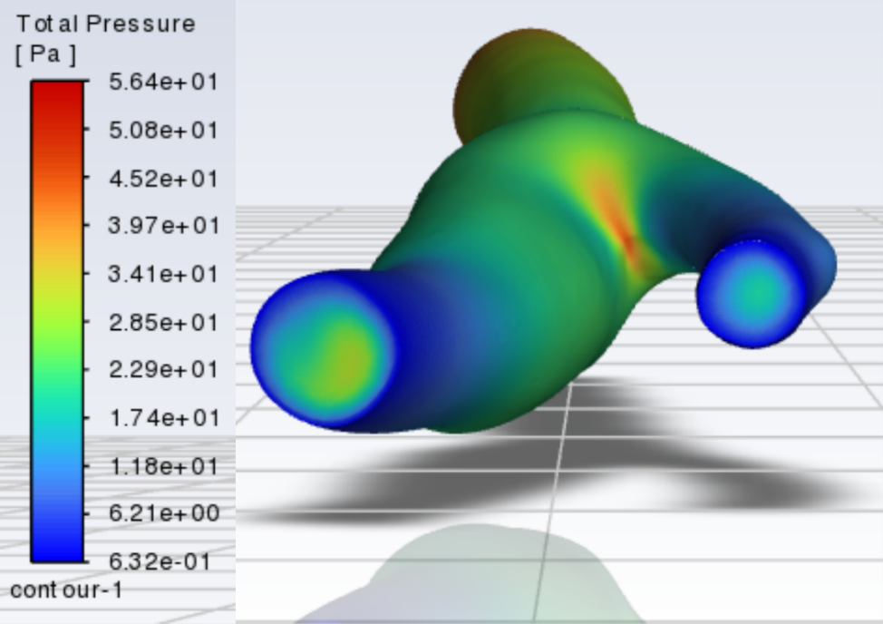

*Figure 26 Shows the Total Pressure Distribution along the Healthy Carotid Artery*

Figure 26 has total pressure contours on carotid bifurcation. The color scale runs from approximately 0.63 Pa (dark blue) to 56.4 Pa (deep red). The 3D view illustrates higher total pressure (yellow-green to red) localized at the apex of the bifurcation (where the common carotid separates into internal and external branches). Here, dynamic (kinetic) energy is converted into stagnation pressure, as flow slows and impinges on the wall [41]. Lower pressure zones (blue to light green) occur in the straight inlet and distal outlets where flow continues with less uniformity (faster) with more of its energy as dynamic pressure than potential energy (static head) [42]. The peak total pressure (~½ ρ u² ≃ 1/2·1060 kg/m³·(0.32 m/s)² ≈ 54 Pa) matches reasonably with theoretical dynamic‐pressure values for carotid velocities [43], confirming that the simulation has reproduced reasonably good approximations of the expected energy exchanges within the bifurcation.

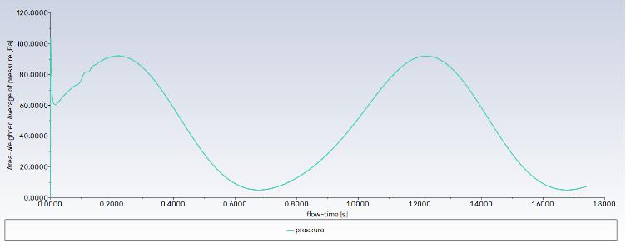

*Figure 27 Shows the Area Weighted-Average of pressure against flow-time graph*

The graph provided illustrates the area-weighted average of static pressure over time for a healthy carotid artery, demonstrating the characteristic pulsatile pressure waveform driven by the cardiac cycle. The graph shows cyclical variations in static pressure over a period of approximately 1 second, corresponding to a typical heart rate. During the systolic phase, the pressure rapidly increases to a peak value of approximately 90 Pa at around 0.2 s and again at 1.2 s. Following the systolic peak, the pressure decreases during the diastolic phase, reaching a minimum value of approximately 5 Pa around 0.8 s. This pulsatile pressure profile, with distinct systolic peaks and diastolic minimums, is consistent with the expected hemodynamic pressure fluctuations in a healthy carotid artery throughout the cardiac cycle.

**4.3 CFD Results on Stenosed Artery**

**4.3.1 25% Stenosis**

a) Velocity

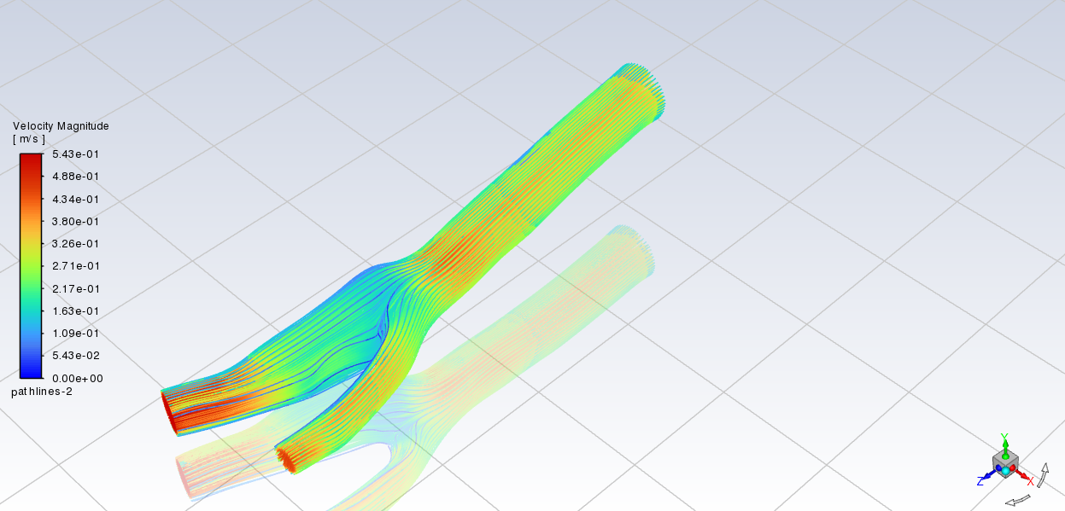

*Figure 28 Shows the Velocity Streamlines for the 25% Stenosed Carotid Artery*

Figure 28 shows the velocity magnitude streamlines in a healthy carotid artery bifurcation model that was created through Computational Fluid Dynamics (CFD) analysis, indicating velocities from notes of 0.00 m/s to a maximum of 0.543 m/s as shown in the colour bar. Under normal conditions, the flow in a healthy carotid artery, the common carotid artery (larger vessel entering from the right), generally should represent a relatively parabolic velocity profile during systole, which at the bifurcation becomes divided into the internal and external carotid arteries. Due to the complexity of the bifurcation (and the carotid bulb), there are unique, complex flows that could occur including an area of boundary layer separation and stagnant zone or recirculation areas, and especially for the outer wall of the internal carotid artery, visible yet again in this diagram by the swirling of the streamlines for the inner space due to the lower velocity magnitudes (cooler colours). A higher strength of velocity (in warmer color) is displayed in the arterial portions of the common carotid artery and further up along the inner wall of the bifurcation divider where acceleration of flow is occurring. Spatial velocity is also paramount in changing the wall shear stress distribution that is commonly noted to influence localization and progression of atherosclerosis. CFD studies, such as the one by Gharahi et al. (2015) [44], have observed these typical velocity profiles along with these flow patterns in healthy carotid bifurcations, confirming the computational methods of studying arterial hemodynamics.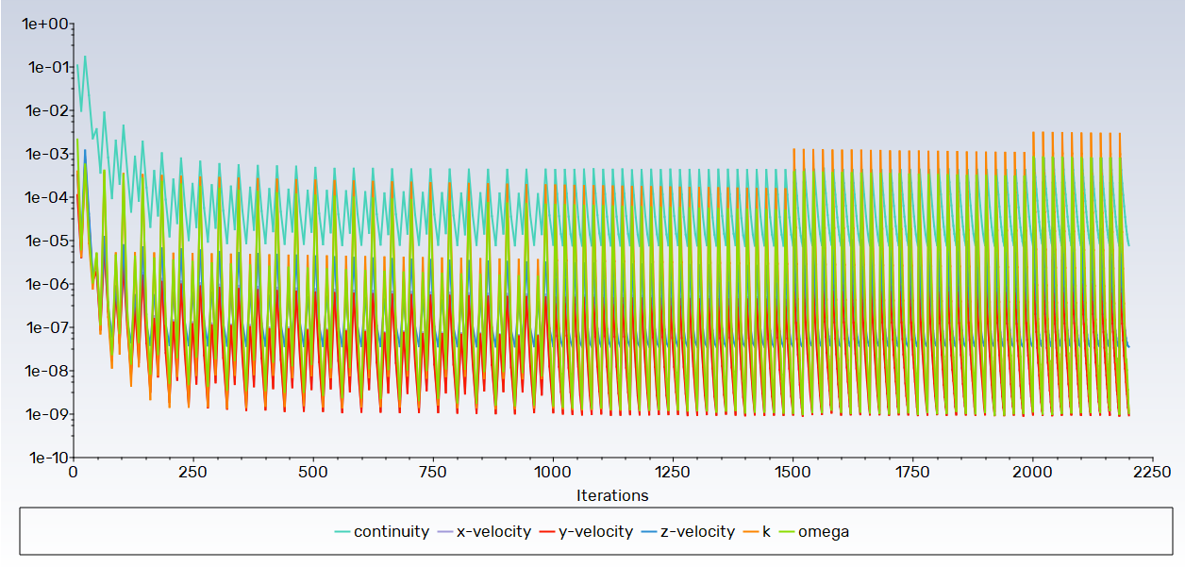

*Figure 29 Shows the scale residuals obtained for the 25% Stenosed Carotid Artery*

The graph shows the convergence history for the Computational Fluid Dynamics simulation of the carotid artery model with a 25% stenosis, and the scaled residuals for continuity, x-velocity, y-velocity, z-velocity, k, and omega as a function of the number of iterations. Upon visual examination, the graph also shows that during the initial transient portion of the solution process, the scaled residuals decrease rapidly and significantly with the number of iterations for all of the solved variables over the first approximately 100-200 iterations. After the transient portion of the solution process, the residuals for the velocity components and continuity oscillate, but remain below 10 − 4, frequently dropping below 10 − 5 and oscillating between approximately 10 − 5 and 10 − 8. The k and omega residuals likewise dropped significantly, but although the k and omega residuals dropped significantly, they oscillated at higher residual magnitudes than the velocity and continuity residuals and primarily stayed above 10 − 2. The residuals dropped over orders of magnitude, with the greatest residual drop being the velocity residual dropping to test a final convergence for Less than 10 − 5, showing that the simulation is nearing and/or has reached numerical convergence that is in accordance with the standard convergence criteria typically used in CFD studies.

b) Wall Shear Stress (WSS)

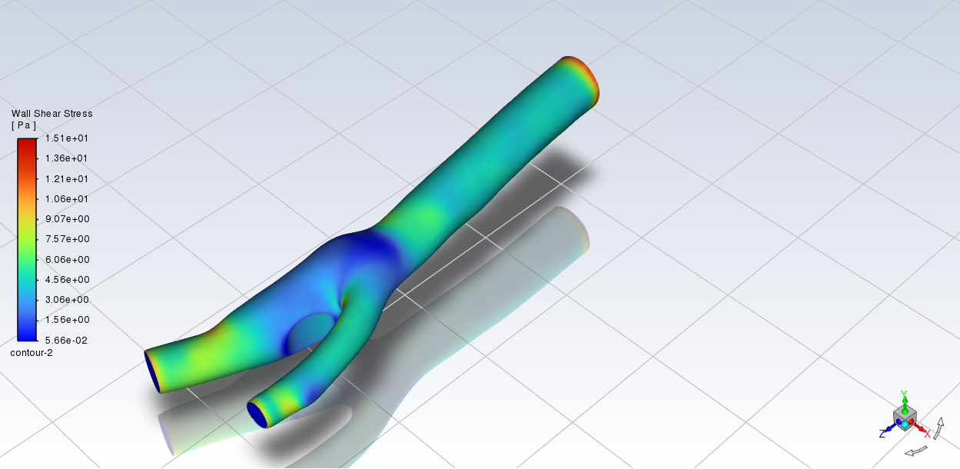

*Figure 30 Shows the Wall Shear Stress Distribution along the 25% Stenosed Carotid Artery*

Figure 30 shows the Wall Shear Stress (WSS) distribution on the wall of a healthy carotid artery bifurcation from Computational Fluid Dynamics (CFD) analysis. The WSS values numerically range from a minimum 5.66e-02 Pa to a maximum 1.51e+01 Pa as shown in the color scale. Theoretically, WSS is a frictional force acting on the endothelium of the artery from the blood as it flows over it and is a really important hemodynamic parameter affecting vascular biology and pathology particularly in the development of atherosclerosis which typcially arises from areas of low WSS and low oscillatory WSS. For all healthy carotid bifurcations, with similar bifurcation morphology, CFD simulations show a typical WSS distribution with a generally high shear stress on the inner wall of the common carotid and the flow divider at the bifurcation from increased accelerated flow and the low, oscillatory areas of the WSS on the outer wall of the carotid bulb were flow separation and re-circulation can occur. The appearance in the image reaches greater WSS (warmer colors) and lower WSS (cooler colours) is consistent with the theoretically predicted WSS patterns for healthy carotid artery hemodynamics. Using CFD to confirm said patterns, the study by Biasetti et al. (2011) [45] was very effective at quantifying the WSS levels and looking for correlations with atherosclerotic plaque lodging. This work by Biasetti et al. (2011) confirms the usefulness of CFD to analyze arterial wall shear stress more specifically.

c) Pressure Distribution

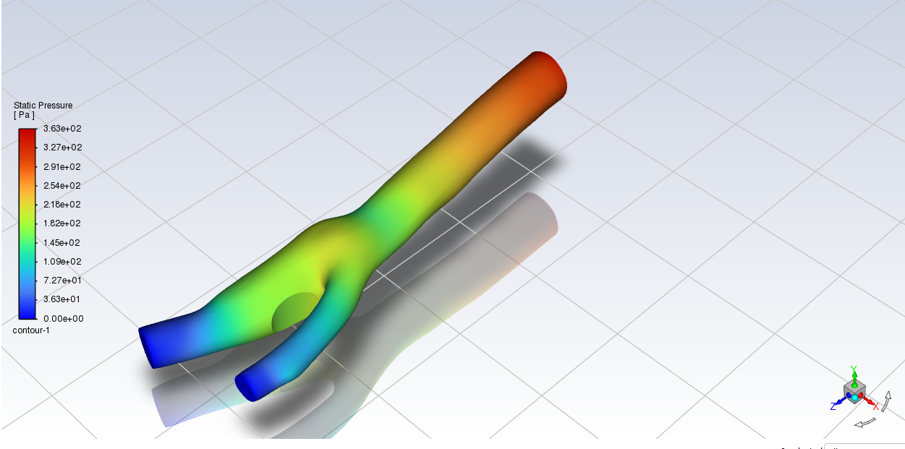

*Figure 31 Shows the Static Pressure Distribution along the 25% Stenosed Carotid Artery*

Figure 31 demonstrates the static pressure distribution illustrated by computational fluid dynamics (CFD) analysis, in a model of a healthy carotid artery bifurcation. The CFD, as shown, reveals a numerical static pressure difference across the arterial lumen range from 0.00 Pa to 3.63e+02 Pa (associated color bar). In fluids, static pressure is one of the fluid pressures contributing to total pressure and can be defined thermodynamically, as distinct from hydrostatic and dynamic fluid pressurization; in the case of blood flowing through an arterial system the static pressure is driven by the heart pump upstream and the amount of vascular resistance downstream. In these CFD simulations of carotid artery branches, static pressure drops in the longitudinal direction of the vessel due to viscous shear losses and due to the slow steady dynamic pressure changes, following Bernoulli's principle, evident at every bifurcation point due to the gas laws (which are associated with uniformity) changing velocity flow along the carotid artery and bifurcation, changing static pressure directions; static pressure was higher at lower velocities through a branch and lower at higher velocities along the carotid artery. Research employing CFD studies of carotid artery flows and hemodynamics, such as Zhao et al 2010 [46], demonstrate the distribution of static pressure and relationship to the separately flowing patterns through the carotid arteries and also anatomical geometry in both healthy and diseased states which emphasizes the nature of static pressures associated with in-vivo hemodynamics.

**4.3.2 50% Stenosis**

a) Velocity

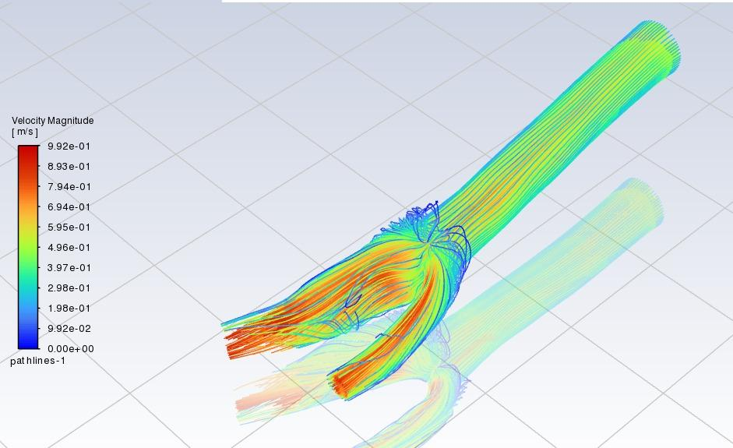

*Figure 32 Shows the Velocity Streamlines for the 50% Stenosed Carotid Artery*

Figure 32 displays the simulation of velocity magnitude contours and streamlines in a carotid artery with a 50% stenosis. The velocity profile is shown through colors and flow lines, which contain information about the direction and speed of the blood. In this case, the peak velocity magnitude through the stenotic segment reaches approximately 0.992 m/s. When compared to the previous analysis of a carotid artery with 25% stenosis, a distinction of approximately 0.53 m/s was seen for peak velocity in that case scenario. As the percentage of stenosis increases, the peak velocity also increases because of the larger decrease in luminal area. There is a high-velocity jet through the stenosis and below the stenosis in a post-stenotic region (especially in the carotid sinus), there seem to be greater flow disturbances in the flow patterns (for example, recirculation zones, flow separation) than observed in the previous case with 25% stenosis. These altered flow patterns (high velocity at stenosis and disturbed flow down stream) are potential hemodynamic effects of the increased stenotic severity [47].

b) Wall Shear Stress (WSS)

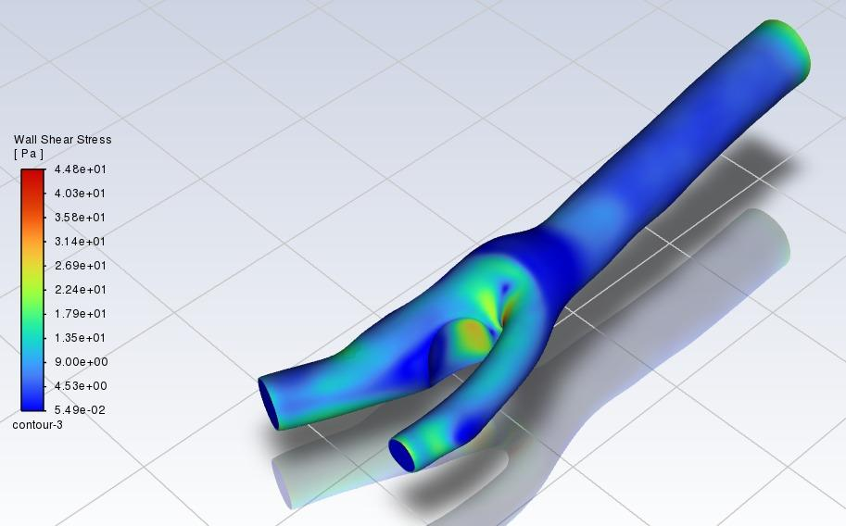

*Figure 33 Shows the Wall Shear Stress Distribution along the 50% Stenosed Carotid Artery*

Figure 33 illustrates the Wall Shear Stress (WSS) profile on the surface of a carotid artery model with a 50% stenosis. The color contour mapping indicates the magnitude of WSS in Pascals (Pa), which range from approximately 5.49e-02 Pa (dark blue) to 4.48e+01 Pa (red). When comparing the 50% stenosis case against that of a 25% stenosis case which showed a peak WSS at approximately 14.9 Pa, the 50% stenosis shows a significant increase in WSS, with a peak value occurring within the constricted region of approximately 44.8 Pa due to the higher flow acceleration through the more severely reduced lumen. High WSS regions are focused at the throat of the stenosis [49]. On the other hand, we see areas of low WSS with low values in the range of approximately 0.0549 Pa, specifically in the carotid sinus downstream of the stenosis. The regions of low WSS exhibited appear to be more extensive in the carotid sinus in the case of the 50% stenosis compared with the 25% stenosis. This is reasonable given the higher severity of the stenosis and the potential development of flow disturbances such as larger recirculation regions. The areas of low WSS represent hemodynamic regions associated with an increased risk of atherosclerotic plaque formation and further progression [48].

c) Pressure Distribution

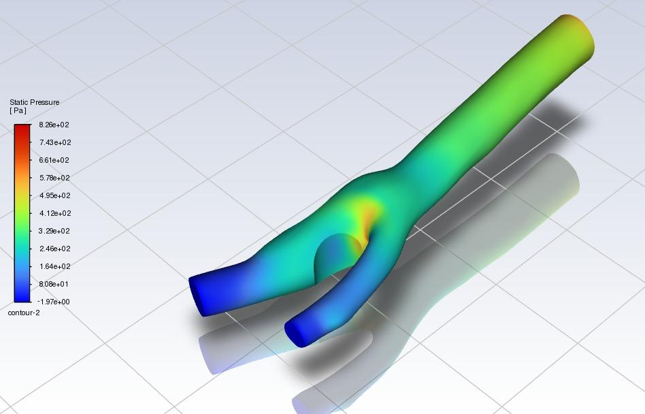

*Figure 34 Shows the Static Pressure Distribution along the 50% Stenosed Carotid Artery*

Figure 34 displays the static pressure at the surface of a carotid artery model with 50% stenosis. The color contour maps the value of static pressure in Pascals (Pa), with values of static pressure ranging from -1.976 Pa (dark blue) to 8.28e+02 Pa (red). Compared to the 25% stenosis case with pressures ranging from about 0.00 Pa to 3.76e+02 Pa, the 50% stenosis has more range, and a much larger pressure drop across the constricted region. The static pressure values upstream of the stenosis were higher, on average, than those for the 25% stenosis case, which agrees with the flow being slowed even earlier, and the velocity flow before the nozzle reduced notably [50]. There was a rapid decline in static pressure at the stenosis and a corresponding drop in pressure immediately downstream of the stenosis. These downstream values are clearly at much lower minimum static pressure than the minimum static pressure derived from the 25% stenosis case. The increased flow acceleration and viscous losses due to greater loss of flow area created a larger pressure drop across the 50% stenosis compared to the 25% stenosis, and we observed some increase in static pressure downstream, but there were likely many problems with full recovery and static pressures because of the lasting pressure gradients in the disturbed flow region along the wall. The differences in static pressure values and the difference in static pressure drops across the different severity of stenoses represent two important parameters of hemodynamic status occurring in history related to the carotid artery disease conditions.

**4.3.3 75% Stenosis**

a) Velocity

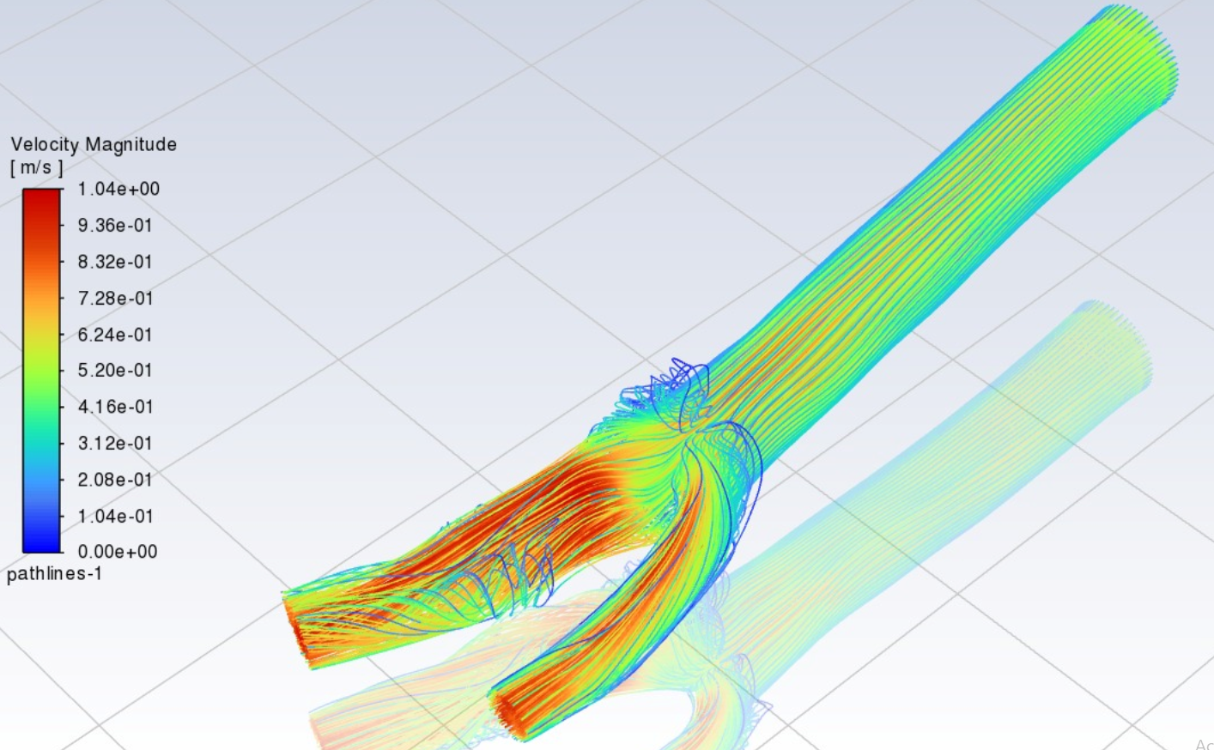

*Figure 35 Shows the Velocity Streamlines for the 75% Stenosed Carotid Artery*

It can be seen from Figure 35, the simulated velocity magnitude contours and streamlines within a carotid artery with a 75% stenosis. The velocity profile indicates both speed and directional flow lines through color and flow lines. The peak velocity magnitude of approximately 1.04 m/s occurs in the severely narrowed stenotic segment. By comparison, the peak velocity for the 25% and 50% stenosis cases approached 0.53 m/s and 0.992 m/s, respectively. The velocity magnitude in this case is significantly higher or twice the peak velocity, as one would expect, because of the acceleration required to maintain the flow rate through the substantially reduced lumen. This places a blood vessel in a condition where it is experiencing a significantly accelerated stream jetly from the stenosis [51]. This variation downstream or in the post-stenotic zone is significant. For example, the carotid sinus not only shows extensive and complex flow disturbances with large recirculation zones and or possibly turbulent flow depending on simulation parameters but will result in very serious consequences of altered flow pattern characterized by a very large increase in velocity through the stenosis and complex downstream disturbances. These abnormalities in hemodynamics, represented in this case by high-grade stenosis, are associated with an increased clinical risk and frequently require intervention, especially with degree of obstruction.

b) Wall Shear Stress (WSS)

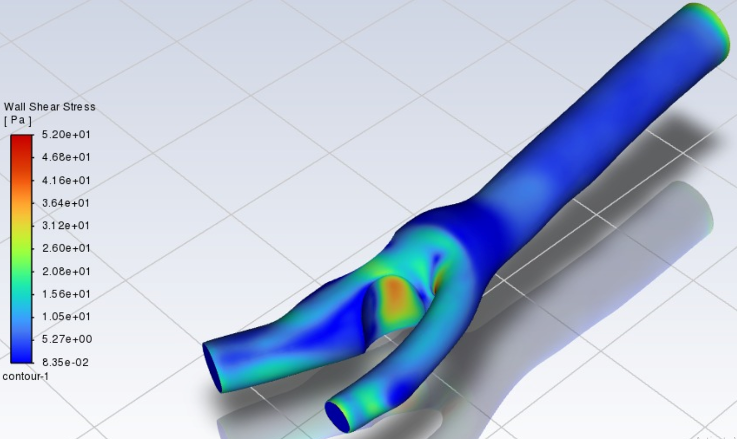

*Figure 36 Shows the Wall Shear Stress Distribution along the 75% Stenosed Carotid Artery*

Figure 36 shows the Wall Shear Stress (WSS) distribution over the surface of a carotid artery with 75% stenosis as the magnitude of WSS in Pascals (Pa) from approximately 8.35× ${10}^{-2}$ Pa (dark blue) to 5.20×101 Pa (red). The peak WSS numerically is about 52.0 Pa within the stenotic segment which is much higher than the peak WSS of approximately 44.8 Pa experienced in the 50% stenosis case or the peak WSS of approximately 14.9 Pa in the 25% stenosis case, and we observed a substantial increase in peak WSS as stenosis severity increased. Theoretically, this comparatively high WSS at the throat of the stenosis occurs due to the high velocity gradients due to the rate of acceleration of blood through the highly reduced lumen area due to stenosis. On the other hand, the image displayed low WSS with regions as low as approximately 0.0835 Pa, and low WSS regions were seen particularly within the carotid sinus downstream of the stenosis. It is theorized that these low WSS regions are due to flow separation and recirculation zones occurring in the area of sudden expansion distal to the stenosis. The areas of low WSS could be expected to be of a more extensive area when compared to lower stenosis severities based on the increased flow disturbances at 75%. From a hemodynamic perspective, regions with chronically low and oscillating wall shear stresses (WSS) are closely linked to both the development and progression of atherosclerotic plaques, whereas high WSS also contributes to plaque development or eventual rupture [52].

c) Pressure Distribution

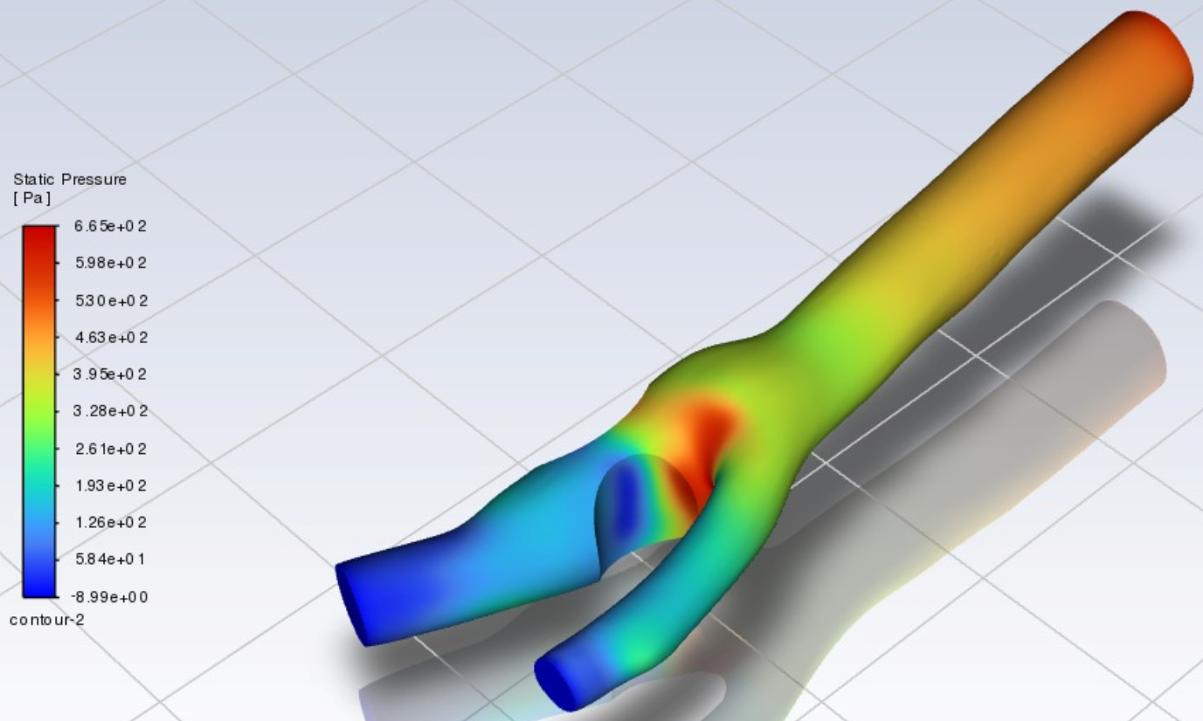

*Figure 37 Shows the Static Pressure Distribution along the 75% Stenosed Carotid Artery*

Figure 37 visualizes the static pressure distribution on the surface of a carotid artery model featuring a 75% stenosis, depicting the magnitude of static pressure in Pascals (Pa) ranging from approximately -8.99 Pa (dark blue) to 6.65e+02 Pa (red). Numerically analyzing the image, high static pressure values, reaching around 665 Pa, are observed upstream of the severe stenosis. Within and immediately downstream of the stenosis, a significant pressure drop occurs, with static pressure values falling to a minimum of approximately -8.99 Pa. Theoretically, this substantial pressure drop is a direct consequence of the marked acceleration of blood flow through the severely constricted lumen and significant energy losses due to viscous effects and flow disturbances. Comparing this to the 25% and 50% stenosis cases, the 75% stenosis demonstrates a considerably larger pressure drop and lower minimum pressure values, highlighting the non-linear increase in hemodynamic impact with increasing stenosis severity. While some pressure recovery is observed distal to the stenosis, the overall pressure loss is much greater at 75% stenosis. This pronounced pressure reduction and altered distribution are critical hemodynamic features of high-grade carotid artery stenosis [53].

**4.4 FSI Results on Stenosed Artery**

**4.4.1 Healthy Artery**

i) Velocity

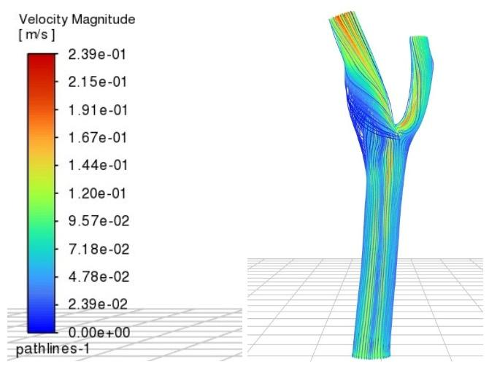

*Figure 38 Shows the Velocity Streamlines for the Healthy Carotid Artery with FSI*

Figure 38 shows the instantaneous velocity magnitude contours and streamlines for a healthy carotid artery as the FSI developed. The colors represent velocity magnitude based from a color map between approximately 0 m/s (dark blue) to 0.239 m/s (red). The flow shows a laminar profile at the common carotid inlet, with the highest velocities in the center of lumen, with lower velocities towards the walls, which is theoretically expected for flow in a pipe. As the flow reaches the bifurcation, the flow separates between the internal and external carotid artery branches. The comparison of these FSI results with the provided CFD velocity results for a healthy artery, show a maximum velocity of 0.24 m/s at peak systole, with a parabolic laminar profile at the inlet and residual parabolic topologies described for both outlets, and shows a very similar peak velocity (approximately 0.239 m/s) and qualitatively similar laminar flow patterns and the bifurcation flow behavior [10]. In theory, FSI simulations consider the elastic deformation of the arterial wall in response to the dynamic blood pressure; this is not accounted for in rigid-wall (or non-deformable wall) CFD simulations. The fluid-structure interaction (FSI) and resulting flexible structure in the model does impact the velocity distribution and magnitude compared to a rigid model. Here, the instantaneous peak velocities are similar for both cases; however, the FSI approach captures the more physiologically relevant dynamic interaction of blood flow with the compliant arterial wall.

ii) Wall Shear Stress

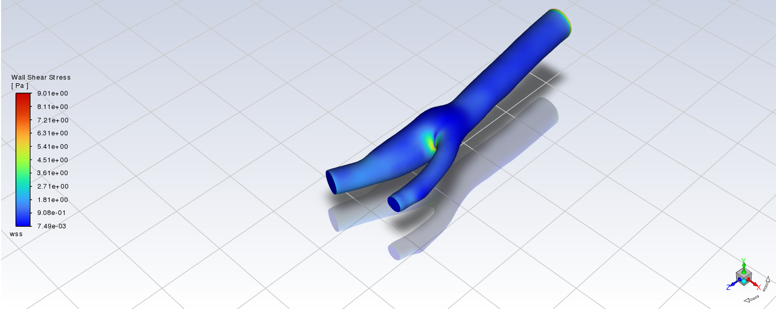

Figure 39 shows the Wall Shear Stress (WSS) in a healthy carotid artery model undergoing Fluid Structure Interaction (FSI) simulation from a numerical solution with values between 7.49 × 10⁻³ Pa to 9.01 Pa. This is also consistent with numerous studies of healthy carotid arteries that provide hemodynamic data confirming typical occurrence of time average WSS values produced from 1 - 7 Pa in straight sections, 0-1 Pa in disturbed flow regions - such as the carotid bulb - and values above 7Pa at the inner apex due to bifurcation / acceleration of blood flow. In principle, WSS is when blood flow applies a tangential force along the arterial wall and is important to endothelial cell function and development of atherosclerosis, which is characterized by low and oscillatory shear stress (OSS), and high stress applied to endothelial cells. Unlike rigid-wall simulations, the FSI methodology is important for accurately representing the interaction between blood flow and a deformable arterial wall, which may result in lower WSS values than fully rigid models and a more realistic representation of actual hemodynamic conditions. As supported by studies such as V. Kumar et al. (2020), the fluid structure interaction study of the stenosed carotid artery that took consideration of the impact from blood pressure demonstrates that through the incorporation of arterial wall compliance the results can provide more accurate distribution of WSS representation and health effects. As illustrated in the image, where the low WSS (deep blue) regions in the carotid bulb, wherein the higher WSS (yellow-green) region occurs at the flow divider, agrees with a reasonable depiction of the ranges numerically, as well as, good depiction of the theoretical understanding of the range in WSS distribution in a healthy carotid bifurcation which can be correlated with the provided CFD results, which demonstrate generally similar pattern and magnitude of WSS in similar regions [54].

**4.4.2 25% Stenosis**

i) Velocity

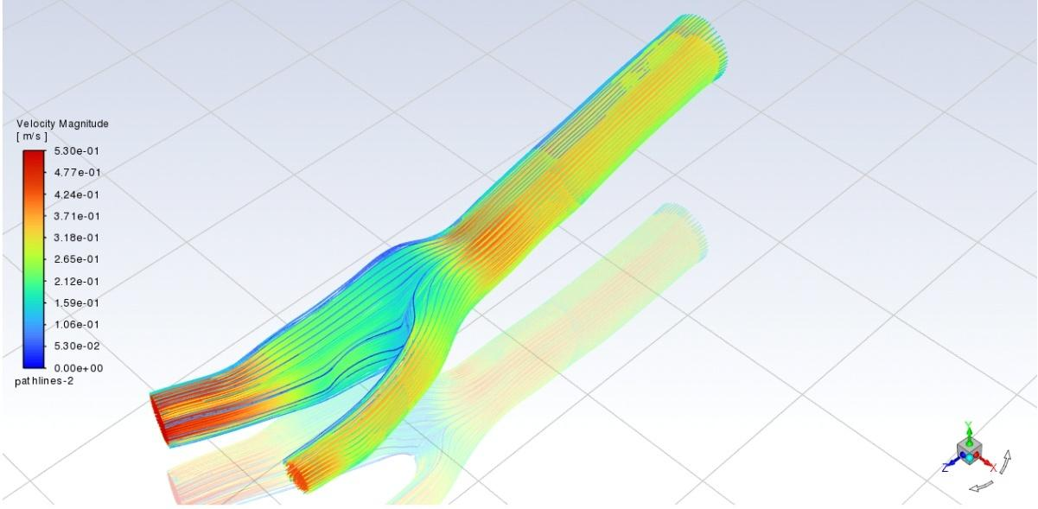

*Figure 40 Shows the Velocity Streamlines for the 25% Stenosed Carotid Artery with FSI*

Figure 40 represent the contours of velocity magnitude and streamline paths in a carotid artery with 25 % stenosis from a Fluid-Structure Interaction (FSI) simulation. The velocity magnitude will be highest at the maximum stenosis opening due to the decreased cross-sectional area as in the CFD provided. This is expected given the mass conservation principle of fluid flow. Downstream from the stenosis images likely show lower velocity regions or potentially some recirculation or separate flow, which we expect in disturbed flow post-stenosis.In theory, while both CFD and FSI simulations reflect the characteristics of blood flow simulations, FSI takes into account the two-way interaction between the fluid environment and the compliant arterial wall, which may influence velocity profiles and wall shear stress patterns, especially in pathological vessels. Compared to a rigid wall CFD simulation, there may be altered velocity patterns and possible lower peak velocities in FSI simulations, as the compliance of the arterial wall allows some of the flow energy to be absorbed. The disturbed flow patterns identified downstream of the stenosis are important for the local hemodynamics and considered to play a relevant role in atherosclerotic disease progression. [55]

ii) Wall Shear Stress

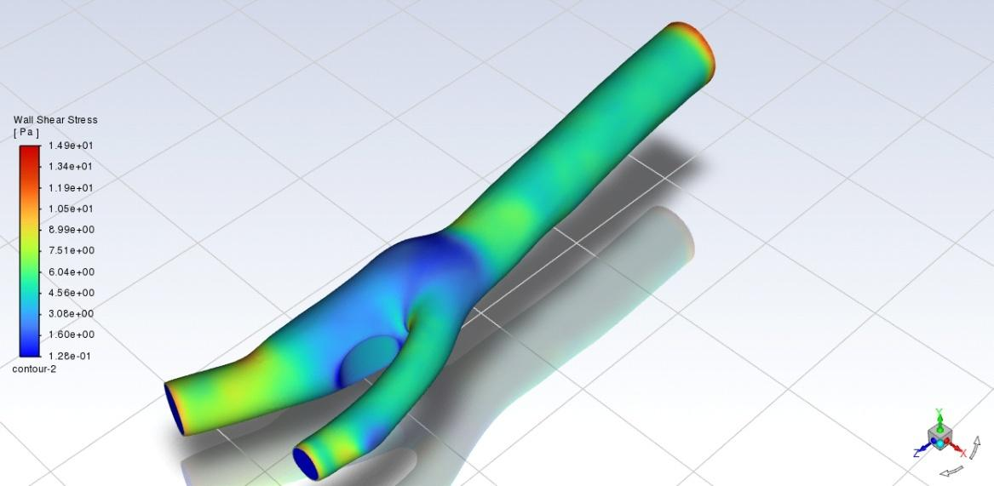

*Figure 41 Shows the Wall Shear Stress Distribution along the 25% Stenosed Carotid Artery with FSI*

Figure 41 shown is a visual of the Wall Shear Stress (WSS) contours from the Fluid-Structure Interaction (FSI) study of a 25% stenosed carotid artery model. From the numerical study WSS ranged from approximately 0.125 Pa (dark blue) to 14.9 Pa (red), as shown in the color bar provided to the right of the model, and is in line with the WSS calculated from the provided rigid wall CFD (Figure 26). The theoretical distribution corresponds with the physiological conditions influencing local flow due to stenosis; areas of higher WSS (red contours) are primarily located in the stenotic throat where the fast flow velocity leads to small boundary layers because of the narrowed lumen. In areas with a lower WSS (blue/cyan contours), these were located in the post-stenotic dilation, specifically in the carotid sinus region, where the boundary layer velocity led to the separation of flow and recirculation, resulting in disturbed flow.These low WSS regions are vital in regards to hemodynamics, as they are intimately related to the localization and advance of atherosclerotic lesions (Caro et al., 1971) [2]. Since we adopt an FSI approach that include wall compliance, which is not the case in rigid-wall simulations, it allows the arterial wall to deform under its own imposed pressure and flow, which may alter local flow patterns, specifically in the post-stenotic zone and affect the size and intensity of the recirculation zones and thus its temporal and spatial distribution of low WSS, a biological factor of atherogenicity [56].

iii) Pressure

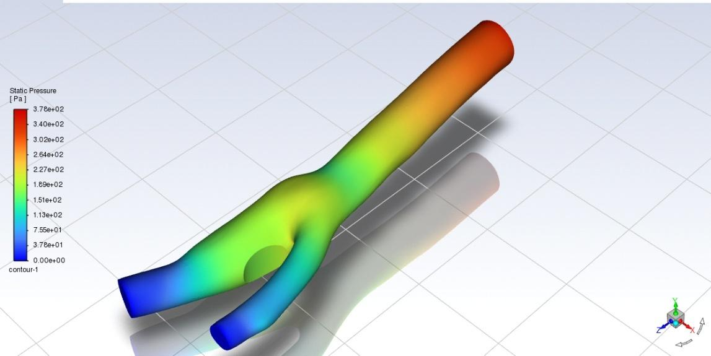

*Figure 42 Shows the Static Pressure Distribution along the 25% Stenosed Carotid Artery with FSI*

Figure 42 above shows the static pressure contour on a 25% stenosed carotid artery model resulting from a Fluid-Structure Interaction (FSI) simulation. Numerical values of the pressure field range between approximately 0.00 Pa (dark blue) and 3.76× ${10}^{2}$ Pa (red), however, the scale is consistent with the accompanying legend (it is worth noting that the range is virtually identical to the CFD results presented in Figure 27). The pressure distribution is consistent with basic hemodynamic theories; there is a region of high pressure in the proximal artery, upstream of the stenosis, where fluid velocity is relatively low. Once the fluid passes through the stenotic constriction, there is a greater loss of static pressure in the stenosis and immediately downstream of the stenosis; this is entirely consistent with the impact of Bernoulli Downstream of the stenosis, some degree of recovery in pressure does occur from the increasing vessel area, although pressure gradients continue to persist within the post -stenotic zone because of the intricate flow phenomena that are also encountered elsewhere, e.g., recirculation, turbulence, etc. This complex flow is also a function of wall compliance that FSI captures. Furthermore, pressure trends will largely correspond with rigid wall CFD simulations. However, FSI has the benefit of considering wall deformation due to the local pulsatile pressure, and it is possible that this asymmetric factor modulates the pressure field, especially under the constraints of the stenosis and under conditions of flow separation. Each of these specific pressures, shear stress, wall shear stress, and oscillatory shear index are intimately related, however wall shear rate changes are most apparent . These factors are vital in further understanding the mechanism of translation of atherosclerosis (Perktold et al.; 1998)[57].

**4.4.3 50% Stenosis**

i ) Velocity 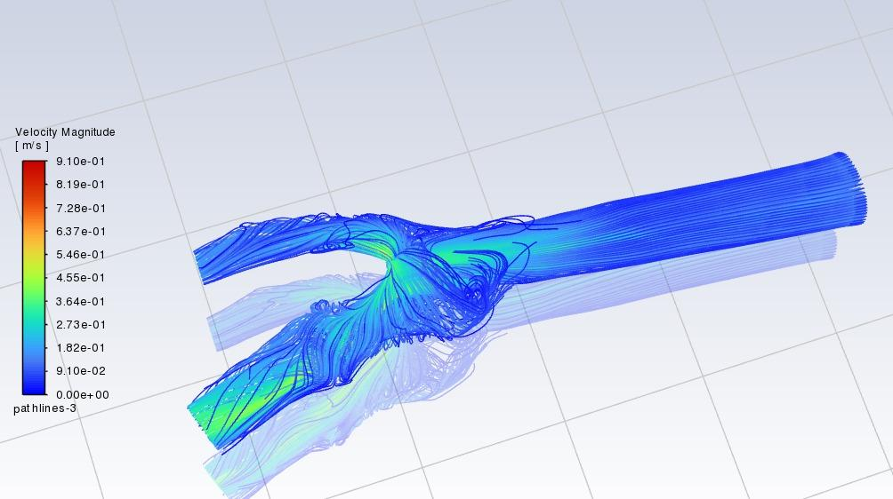

Figure 43 generated from the fluid-structure interaction (FSI) analysis of a 50% stenosed carotid artery at the internal carotid artery (ICA) sinus demonstrates the important biomechanical changes in blood flow induced by the stenosis and the complete coupling of the blood flow with the compliant arterial wall. In the image, there are many regions of varying velocity magnitudes that are indicated by color contours and magnitude streamlines that show the course and speed of blood flow. As seen within the stenotic throat, the velocity has increased significantly relative to the pre-stenotic common carotid artery due to the reduced cross-sectional area associated with the stenosis, imposed by mass conservation (continuity equation). In theory, this acceleration of blood flow through the stenosis creates a high velocity jet that is then followed by separation of blood flow, which creates recirculation zones and subsequently generated disturbed flow in the post-stenotic flow, especially found in the dilated carotid sinus. This turbulent, or disrupted, flow shows lower velocity magnitudes and uncoupled, or chaotic streamlines compared to the flow in the pre-stenotic common carotid artery. From the visual of the FSI analysis in this image, we can physically appreciate the arterial wall's compliance that is inherent in using this method over a rigid-wall Computational Fluid Dynamics (CFD) simulation.

Compliance alters both the velocity profile and magnitude since it allows for wall distension and recoil at every point during the cardiac cycle, which could lead to differing peak velocities and differing disturbed flow regions in respect to rigid-wall models. For example, the steeped wall in Wallace et al. (2023) rigid-wall simulations would have peak velocities and wall shear stress estimates that were invalidly high given that it could not distend in any direction and dissipate some of the fluid energy. Based on our provided CFD results for a 50% stenosis, there was a peak velocity around 0.992 m/s, which also had large flow disturbances the downstream converging flow. An FSI might show a peak velocity slightly less than that predicted using a rigid-wall CFD simulation, given wall compliance; however, the presence of the high-velocity jet and post-stenotic flow disturbances would remain in a similar spatial and temporal context, just with perhaps subtle differences in these waveforms and flow features. This previous research strongly supports the need for FSI, since it is critical to model the complex relationships between the fluid mechanics and arterial walls when looking to better understand the progression of plaque as its rupture risk rises over time [58].

ii) Wall shear stress: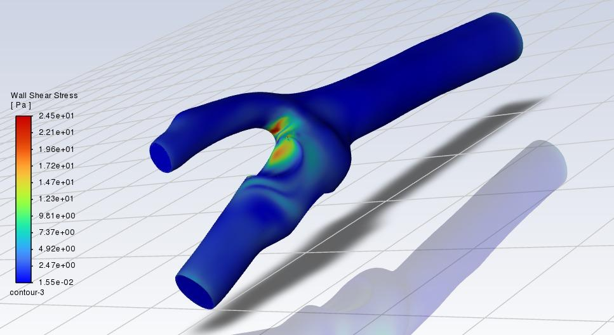

Figure 44 shows the spatial distribution of Wall Shear Stress (WSS) on the surface of a 50% stenosed carotid artery at the ICA sinus generated from an FSI simulation. Numerically, the color contour WSS ranges from the lowest value of approximately 1.55×10−2 Pa (dark blue) to the highest value of approximately 2.45×101 Pa (red). Theoretically, WSS is proportional to the shear rate at the wall, and is highly dependent on blood velocity gradients. As expected for a stenosed vessel, the image shows that WSS increases considerably at the narrowest point of the stenosis (the throat) where blood flow is at its highest velocity. The region of high WSS (red and orange) is therefore consistent with theoretical understanding of the acceleration of flow through a reduced cross-section. In contrast to the post-stenotic region, particularly the carotid sinus region, which has widespread low WSS (shown in blue), this finding is attributable to flow separation and recirculation zones, as well as disturbed flow downstream of the stenosis, all of which are aggravated by the sudden expansion of the lumen in the sinus.There are similarities and may be differences, between the results of these FSI simulations and the rigid-wall CFD data provided. Both of these simulations showed high WSS values at the stenosis throat and low WSS values in the post-stenotic sinus. The peak WSS in the FSI simulation was approximately 24.5 Pa, which was less than the peak WSS from the rigid-wall CFD analysis (approximately 44.8 Pa). Theoretically, the difference lies in the arterial wall compliance that is incorporated into the FSI simulations. The compliant wall distension during systole may dissipate some pressure load and change the velocity profile near the wall, which may change shear rates and therefore WSS peaks since all of the fluid energy has the potential to affect pressure and viscous forces against an immovable boundary when modelling a rigid vessel. Likewise, the size and attributes of the low WSS spaces that develop in the carotid sinus may vary between the FSI and rigid-wall simulations considering wall movement influences flow separation and recirculation. These low WSS regions are hemodynamically important because they are associated with regions that can predispose endothelial dysfunction and atherosclerotic plague development [59].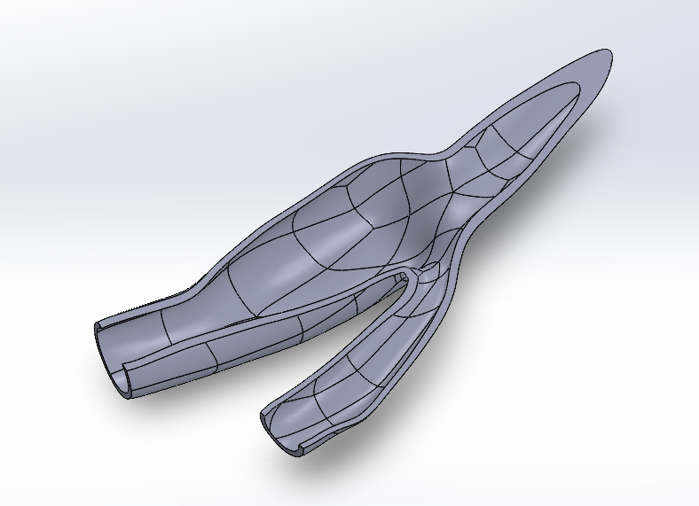

**4.4.4 75% Stenosis**

i) Velocity magnitude: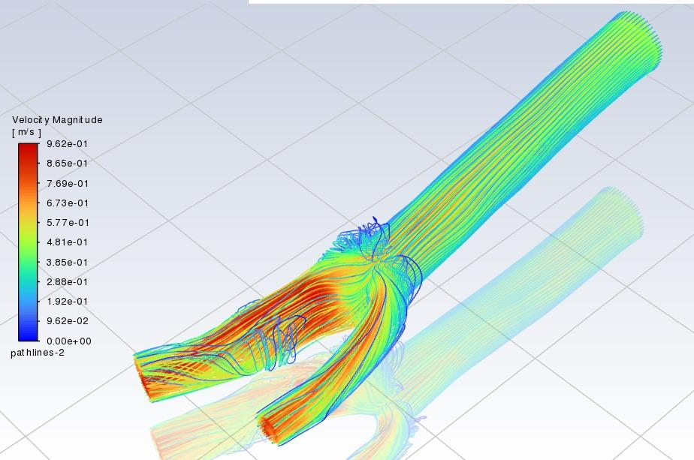

Figure 45 produced by Fluid-Structure Interaction (FSI) analysis, we see the velocity field in a 75 percent stenosed carotid artery, focusing again on the Internal Carotid Artery (ICA) sinus. As shown numerically by the colors in the image, the magnitudes of blood flow velocity are indicated by varying colors, with warmer colors representing higher velocities and cooler colors being lower velocities. We anticipate the highest velocities to occur at the narrowest section of the stenosis, and we would expect the lowest and more complex velocity distributions (potentially including recirculation zones) to take place in the post-stenotic region, particularly with the larger geometry of the ICA sinus.

The notable increase in velocity at the stenosis throat is theoretically due to continuity, which states that the product of area and velocity must be constant for an incompressible fluid; therefore, a decrease in area must increase velocity to maintain q. Downstream of stenosis, the sudden expansion and disturbed flow will cause a decrease in mean velocity and the introduction of secondary flow patterns. Comparing the FSI-derived velocity profile with the computational fluid dynamics (CFD) results shows similar trends for peak velocities at the stenosis (approximately at 1.04 m/s in the CFD analysis) and disturbed flow in the post-stenotic region. There could be minor differences in quantitative results between the two studies due to the effect of arterial wall compliance in the FSI method, which could affect fluid dynamics used in the study [60].

ii) Wall Shear Stress 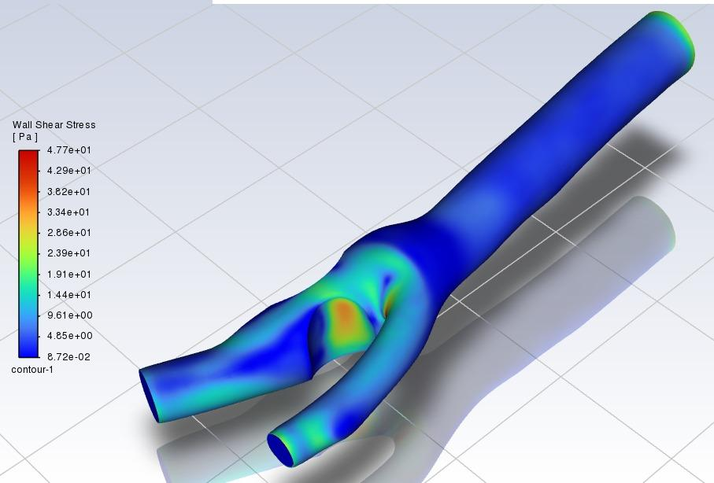

Figure 46 shows the Wall Shear Stress (WSS) in the 75 percent stenosed carotid artery—the Internal Carotid Artery (ICA) sinus—through Fluid-Structure Interaction (FSI) analysis. The numerical color bar indicates the corresponding magnitude of WSS in Pascal (Pa), ranging from a minimum of approximately 8.72e-02 Pa (dark blue) to a maximum of 4.77e+01 Pa (red). The image has visually illustrated that greater WSS is concentrated at the throat of the stenosis, transitioning to lower WSS values downstream in the post-stenotic region, especially displayed in the dilated ICA sinus. Theoretically, one would observe high WSS at the stenosis from the increased flow velocity, which will result in an increase in viscous forces acting on the arterial wall. In contrast, regions of low WSS in the carotid sinus, distal to the stenosis, are attributable to flow separation and recirculation zones developing in the region of geometric expansion. Both these FSI result and the CFD analysis of a 75 percent stenosed carotid artery provided consistent evidence of high WSS developing at the stenosis and low WSS developing in the post-stenotic sinus. The peak numerical WSS developed in the CFD (approximately 52.0 Pa) is slightly higher than the peak that developed in this FSI simulation (approximately 47.7 Pa). This difference could be due to the incorporation of arterial wall deformation and compliance in the FSI model being able to influence the fluid dynamics and therefore the WSS, which will invariably be different from the WSS developed in the CFD model [61].

iii) Pressure

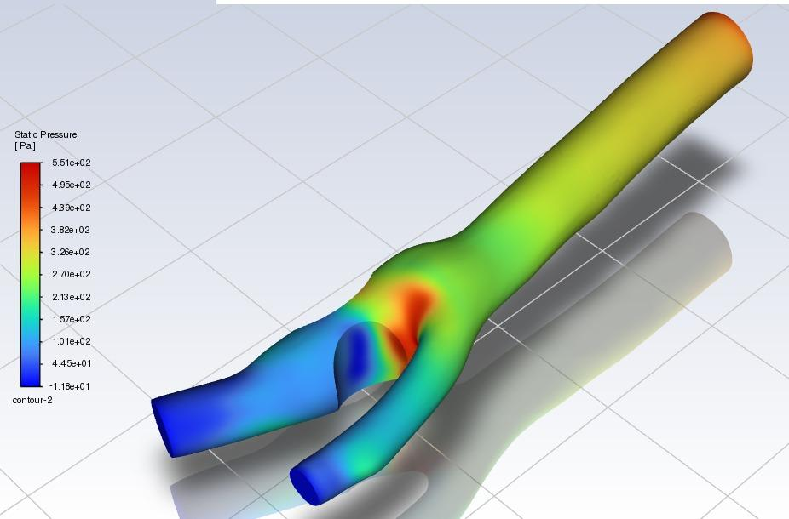

Figure 47, resulting from a Fluid-Structure Interaction (FSI) analysis, depicts the static pressure distribution in a carotid artery with 75 percent stenosis (focusing on the ICA sinus). Numerically, the color scale in the image quantifies the static pressure, which in most cases is in Pascals (Pa) with warmer colors exhibiting higher pressure and cooler colors exhibiting lower pressure. The image should show an increase in static pressure at the location proximal to the stenosis with a substantial drop in pressure within the constricted lumen, and a partial recovery of pressure downstream of the stenosis, particularly within the area of the ICA sinus.

In an FSI context, the high pressure upstream of the stenosis is a result of flow impedance caused by the stenosis (narrowing). The large drop in pressure across the stenosis is due to the increased velocity (resulting from Bernoulli's principle) and viscous energy losses that occur as blood moves through the narrower cross-section. The degree of pressure recovery downstream is not as high, due to turbulence and energy losses continuing to influence the streamwise flow. When you compare the FSI result to the CFD, the overall pattern should be consistent, as defined by high pre-stenotic pressure, a large loss of pressure across the stenosis, followed by lower post-stenotic pressure. Taking into account the reported peak pressure upstream, near to 665 Pa, and minimum pressure, near to -8.99 Pa, similar to, or within the stenosis, definite evidence of a considerable pressure gradient exists. Minor differences in quantitative values for FSI and CFD could possibly be influenced due to the inclusion of the compliance of the arterial walls compared to the CFD analysis [62].

**Comparison of CFD & FSI Results**

The table below presents a quantitative comparison between Computational Fluid Dynamics (CFD) and Fluid-Structure Interaction (FSI) simulations for varying levels of carotid artery stenosis: Healthy (0%), 25%, 50%, and 75%. The comparison includes peak velocity (in m/s) and wall shear stress (WSS, in Pa) at each stenosis level. Additionally, the percentage differences between the CFD and FSI results are calculated to highlight the deviations attributed to the influence of structural deformation in FSI modeling.

| Stenosis Severity | CFD Velocity (m/s) | FSI Velocity (m/s) | Velocity % Difference | CFD WSS (Pa) | FSI WSS (Pa) | WSS % Difference |
| --- | --- | --- | --- | --- | --- | --- |
| Healthy | 0.251 | 0.24 | 4.38 | 9.31 | 9.01 | 3.22 |
| 25% | 0.543 | 0.53 | 2.39 | 15.1 | 14.7 | 2.65 |
| 50% | 0.992 | 0.91 | 8.27 | 44.8 | 42.87 | 4.31 |
| 75% | 1.04 | 0.962 | 7.5 | 52 | 47.7 | 8.27 |

Table IV: Comparison of CFD and FSI Results for Various Stenosis Severities

These results demonstrate that FSI simulations tend to yield slightly lower values for both velocity and wall shear stress as compared to CFD-only simulations. This is attributed to the fact that FSI accounts for the compliant nature of arterial walls, which undergo deformation under pulsatile flow conditions. The difference becomes more pronounced at higher levels of stenosis, where flow-induced forces are greater, thus emphasizing the significance of including structural response in hemodynamic analyses for realistic predictions.

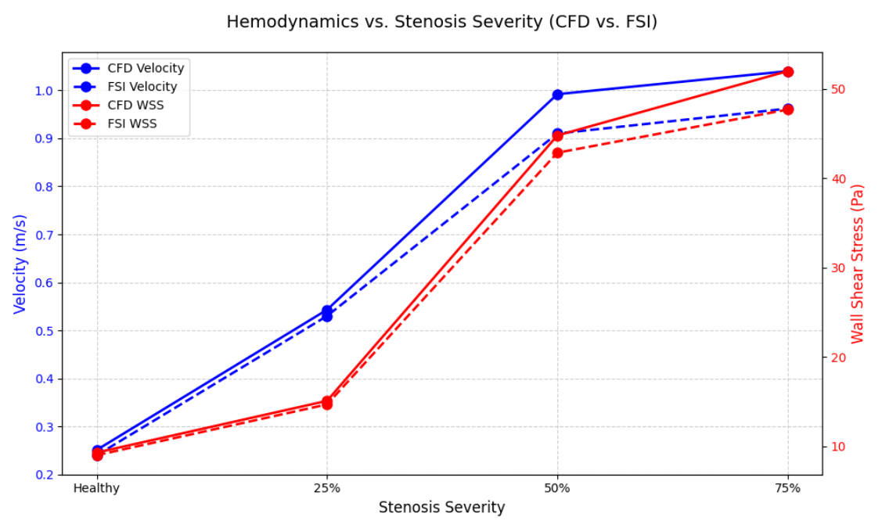

**Future Work**

While the findings of this project share an important perspective on the hemodynamics quantifying the flow of stenosed carotid arteries using CFD and FSI methods, there are numerous opportunities for improvement to increase the clinical relevance and technical fidelity of the project. One potential area for future work would include modeling patient-specific carotid artery geometries derived from CT or MRI images. Patient specific geometries differ from idealized or established geometries as they can characterize the distinct anatomical features of arteries, including curvature, diameter variation, and true stenosis. The addition of patient-specific geometries would improve the fidelity of the simulation results, aid in the development diagnostic tools, personalized follow-ups, and create treatment plans to better reflect the realities of hospital medicine, thus bringing the work of the simulations closer to actual applications.

An additional exciting extension of this research is the inclusion of heat effects specifically based on the simulation of High-Intensity Focused Ultrasound (HIFU). HIFU is a non-invasive medical treatment that uses focused ultrasound waves to raise the temperature in a defined area of tissue. With respect to atherosclerosis, the heat could be used to soften or dissolve plaques causing the arterial constriction. If heat transfer physics were added to the present model, it would be able to simulate how the material properties of the stenosis and the artery walls can change as focused heating occurs. These types of simulations would be important in developing thermal therapy as either an alternative or addition to conventional methods of treatment such as angioplasty and stenting, looking at the safety and viability of this option.

In addition, an important area of exploration is whether heating the stenotic region has any effect on the total hemodynamic status of the artery. For example, if RF hyperthermia locally reduces the volumetric plaque or plaque stiffness, one would expect changes to blood velocity profiles, pressure gradients, and wall shear stress (WSS) distributions. These are key hemodynamic parameters important to the understanding of cardiovascular health; knowing these top values are also instrumental in predicting future plaque rupture, thrombosis and disease progression. Identifying and analyzing hemodynamic changes pre- and post-heating will also provide additional insights into the status of using HIFU to normalize flow and re-establish a healthy arterial condition.

To represent these complex interactions more faithfully, the current model may be extended to include multi-physics coupling to represent fluid dynamics (namely pulsatile blood flow), solid mechanics (arterial wall deformation), and heat transfer, a procedure which is commonly referred to as thermal-fluid-structure interaction (TFSI). This integration would allow simultaneous representation of the pulsatile blood flow, arterial wall deformation, in addition to modeling of the temperature distribution due to localized heating. Comprehensively solving these coupled phenomena will further enable future work not only to investigate the mechanical and thermal response of the artery, but also the interaction between these responses. For instance, what is the impact of arterial wall deformation on heat distribution? In turn, what is the influence of the heating on arterial wall stiffness and motion? The answers to these questions are essential for further applying the core concepts of computational hemodynamics in conjunction with therapeutic interventions.

In conclusion, incorporating these more advanced features would enhance the realism, predictive capability, and clinical utility, of the model. In addition, it would promote a more multi-faceted, comprehensive approach to examining how simulation-based tools may be applied toward design of non-invasive treatments, through surgical planning, and ultimately towards patient-specific risk stratification.

**Conclusion**

This thesis has provided a thorough analysis of blood flow through stenosed carotid arteries through a fluid–structure interaction (FSI)–coupled Computational Fluid Dynamics (CFD) investigation on hemodynamic and biomechanical responses throughout the different degrees of stenosis. FSI was effective in fully analyzing the interaction of vascular compliance and site-specific localized wall shear stresses. The increased maxima at the stenotic throat, which cannot be characterized by rigid-wall models, were validated following repeated mesh and sensitivity studies. The non-linear increases in trans-stenotic pressure gradients with increasing constriction demonstrably provide relevance to consider in the context of cerebrovascular perfusion and potential patient-centered impairments beyond recognized clinical cut-offs. Because the FSI framework included elastic properties, stress distributions were reduced compared to the rigid model and confirmed vascular compliance and patient-to-patient variability as determinants of site-specific local biomechanical loading. The emergent comparative findings highlight the importance of conducting physiologically accurate model comparisons in-periinterventional planning and may aid clinicians by informing the future optimization of stent geometries to minimize thrombogenic recirculation regions. The idealized geometries and the assumptions of Newtonian fluids allowed for far-reaching inferences. However, these study limitations suggest that patient-specific arterial reconstructions and non-Newtonian analyses are necessary under pulsatile flow conditions. Future work will be focused on experimental validation as designated with in vitro flow phantoms and imaging capabilities to benchmark the computational predictions with consideration to translational application. The primary contribution of this work is the use of fluid and structural solvers, which provides a full characterisation of the stenotic vascular behaviour under physiologically relevant loads. Overall, the developed CFD-FSI methodology provides a new biomechanical understanding of carotid stenosis, and this study establishes a high-quality computational framework that could be translated to either fundamental research or personalized vascular treatment protocols. In conclusion, the work provided lays the groundwork for better diagnoses and individual threshold for interventions that could ultimately improve patient outcomes in managing cerebrovascular diseases.

**References**

[1] Yang J, Zhang Y, Xue J, et al. Hemodynamic effects of stenosis with varying severity in different segments of the carotid artery using computational fluid dynamics. *Sci. Rep.* 2025;15:4896.

[2] Albadawi M, Abuouf Y, Elsagheer S, et al. Influence of Rigid–Elastic Artery Wall of Carotid and Coronary Stenosis on Hemodynamics. *Bioengineering* 2022;9(11):708.

[3] Schollenberger J, Osborne NH, Hernandez-Garcia L, Figueroa CA. A combined computational fluid dynamics and arterial spin labeling MRI modeling strategy to quantify patient-specific cerebral hemodynamics in cerebrovascular occlusive disease. *Front. Bioeng. Biotechnol.* 2021;9:722445.

[4] Ho NN, Lee KY, Lee S-W. Uncertainty quantification of computational fluid dynamics-based predictions for fractional flow reserve and wall shear stress of the idealized stenotic coronary. *Front. Cardiovasc. Med.* 2023;10:1164345.

[5a] Tu, J. Inthavong, K., & Wong, K. K. L. (2015). Computational Hemodynamics-Theory, Modelling and Applications. Springer.

[5] S. H. Lee, S. Kang, N. Hur, and S.-K. Jeong, “A fluid-structure interaction analysis on hemodynamics in carotid artery based on patient-specific clinical data,” *J. Mech. Sci. Technol.*, vol. 26, no. 12, pp. 3821–3831, Dec. 2012, doi: 10.1007/s12206-012-1008-0.

[6] E. Earl and H. Mohammadi, “Biomechanics of Human Blood,” in *Biomechanics*, H. Mohammadi, Ed., IntechOpen, 2019. doi: 10.5772/intechopen.78305.

[7] N. Kumar, S. M. A. Khader, R. Pai, S. H. Khan, and P. A. Kyriacou, “Fluid structure interaction study of stenosed carotid artery considering the effects of blood pressure,” *Int. J. Eng. Sci.*, vol. 154, p. 103341, Sep. 2020, doi: 10.1016/j.ijengsci.2020.103341.

[8] H. Gharahi, B. A. Zambrano, D. C. Zhu, J. K. DeMarco, and S. Baek, “Computational fluid dynamic simulation of human carotid artery bifurcation based on anatomy and volumetric blood flow rate measured with magnetic resonance imaging,” *Int. J. Adv. Eng. Sci. Appl. Math.*, vol. 8, no. 1, pp. 46–60, Mar. 2016, doi: 10.1007/s12572-016-0161-6.

[9] E. Fatahian, N. Kordani, and H. Fatahian, “The Application of Computational Fluid Dynamics (CFD) Method and Several Rheological Models of Blood Flow: A Review”.

[10] D. Lopes, H. Puga, J. C. Teixeira, and S. F. Teixeira, “Influence of arterial mechanical properties on carotid blood flow: Comparison of CFD and FSI studies,” *Int. J. Mech. Sci.*, vol. 160, pp. 209–218, Sep. 2019, doi: 10.1016/j.ijmecsci.2019.06.029.

[11] N. Kaid *et al.*, “Unveiling hemodynamic pulsatile flow dynamics in carotid artery stenosis: Insights from computational fluid dynamics,” *AIP Adv.*, vol. 14, no. 6, p. 065128, Jun. 2024, doi: 10.1063/5.0216867.

[12] D. W. Holdsworth, C. J. D. Norley, R. Frayne, D. A. Steinman, and B. K. Rutt, “Characterization of common carotid artery blood-flow waveforms in normal human subjects,” *Physiol. Meas.*, vol. 20, no. 3, pp. 219–240, Aug. 1999, doi: 10.1088/0967-3334/20/3/301.

[13] C. G. Caro, T. J. Pedley, R. C. Schroter, W. A. Seed, and K. H. Parker, *The Mechanics of the Circulation*, 2nd ed. Cambridge University Press, 2011. doi: 10.1017/CBO9781139013406.

[14] Modeling Dynamics of the Cardiovascular System Using Fluid-Structure Interaction Methods. Journal: *Biomechanics and Modeling in Mechanobiology* (2023). DOI: [10.1007/s10237-023-01737-y](https://doi.org/10.1007/s10237-023-01737-y)

[15] Fluid Structure Interaction Versus Rigid-Wall Approach in the Study of Carotid Bifurcation. Journal: *PMC* (2022). DOI: [10.1186/s12938-016-0258-y](https://doi.org/10.1186/s12938-016-0258-y). PMCID: PMC9542585

[16] Fluid-Structure Interaction Simulations of Repaired Type A Aortic Dissection. Journal: *BioMedical Engineering Online* (2015). PMID: 35774287. DOI: [10.1186/s12938-015-0032-6](https://doi.org/10.1186/s12938-015-0032-6)

[17] A Fluid–Structure Interaction Model of the Left Coronary Artery. Journal: *PMC* (2023). DOI: [10.1007/s10237-023-01737-y](https://doi.org/10.1007/s10237-023-01737-y). PMCID: PMC11063795

[18] Fluid-Structure Interaction Explained. Author: Ansys Inc. Source: *Ansys Blog* (March 1, 2022).

[19] Fluid–Structure Interaction. Authors: Wikipedia contributors. Source: *Wikipedia* (Retrieved April 28, 2025).

[20] Fluid-Structure Interaction (FSI) Simulation for Studying the Impact of Atherosclerosis on Hemodynamics, Arterial Tissue Remodeling, and Initiation Risk of Intracranial Aneurysms. Journal: *Biomechanics and Modeling in Mechanobiology* (2022). PMID: 35697948. DOI: [10.1007/s10237-022-01597-y](https://doi.org/10.1007/s10237-022-01597-y). PMCID: PMC9626433

[21] Ojaare, M. G., Annongu, T. I., Msuega, C. D., Mohammad, H. O., Farati, A., Alexander, A., & Umer, B. P. (2021). Carotid artery diameter assessment in men and women and the relation to age, sex and body mass index using ultrasonography. *International Journal of Advances in Medicine*, *8*(9), 1274. <https://doi.org/10.18203/2349-3933.ijam20213234>

[22] Perktold, K., Resch, M. And Peter, R. O., 1991. Three-dimensional numerical analysis of pulsatile flow and wall shear stress in the carotid artery bifurcation. *Journal of biomechanics, 24(6),* pp.409-420.

[23] Fragomeni, G. (2023) ‘Newtonian and non-Newtonian blood model, a comparative study on large and small vessels’, in *12th International Workshop on Innovative Simulation for Healthcare; 20th International Multidisciplinary Modeling & Simulation Multiconference*, Article 007. doi: 10.46354/i3m.2023.iwish.007

[24] Vijayaratnam, P.R.S., O’Brien, C.C., Reizes, J.A., Barber, T.J. and Edelman, E.R. (2015) ‘The Impact of Blood Rheology on Drug Transport in Stented Arteries: Steady Simulations’, *PLoS One*, 10(6), e0128178. doi: 10.1371/journal.pone.0128178

[25] Mahrous, S., Che Sidik, N.A. and Saqr, K.M. (2020) ‘Investigation of Newtonian and Power-Law Blood Flow Models in a 180° Curved Pipe at Low to Medium Shear Rate’ [online].

[26] ANSYS, Inc. (2022) ‘What is the difference between patch dependent meshing and patch independent meshing?’, *ANSYS Innovation Space Knowledge Forums*, 6 June.

[27] ANSYS, Inc. (2022) ‘ANSYS mesh methods explained’, *FeaTips*, 27 December.

[28] Mallett Technology, Inc. (2010) *ANSYS Meshing Solutions 13.0*, Mallett.com.

[29] Lafifi, M.M. (2019) *Meshing Tutorial ANSYS*, ResearchGate.

[30] Espublisher (n.d.) *Meshing Techniques for Advanced Simulations*, ESPublisher.com.

[31] Fluid-structure interaction study of hemodynamics and its biomechanical influence on carotid artery atherosclerotic plaque deposits Ayodele James Oyejide a,1 , Adetokunbo Andrew Awonusi b,1 , Ebenezer Olubunmi Ige a,c,*

[32] Vaia (n.d.) Velocity profile in a pipe.

[33] Ngo, M.T., Kim, C.I. and Jung, J. (2019) ‘Four-dimensional flow magnetic resonance imaging for assessment of velocity magnitudes and flow patterns in the human carotid artery bifurcation: Comparison with computational fluid dynamics’, Diagnostics, 9 (4), p. 223. doi: 10.3390/diagnostics9040223.

[34] Sang Hyuk Lee, Seongwon Kang Nahmkeon Hur and Seul-Ki Jeong, A fluid-structure interaction analysis on hemodynamics in carotid artery based on patient-specific clinical data, Journal of Mechanical Science and Technology 26 (12) (2012) 3821-3831.

[35] Gijsen, F. et al. (2019) ‘Expert recommendations on the assessment of wall shear stress in human coronary arteries: existing methodologies, technical considerations, and clinical applications’, European Heart Journal, 40 (41), pp. 3421–3433. doi: 10.1093/eurheartj/ehz551.

[36] Dolàn, J.M. and Meng, H. et al. (2013) ‘High wall shear stress and spatial gradients in vascular pathology: a review’, Annals of Biomedical Engineering, 41 (7), pp. 1411–1427. doi: 10.1007/s10439-012-0695-0.

[37] Xu, Y. et al. (2011) ‘Effect of spatial gradient in fluid shear stress on morphological changes of endothelial cells’, Biochemical and Biophysical Research Communications, 408 (3), pp. 381–386. doi: 10.1016/j.bbrc.2011.03.084.

[38] Zhang, L. et al. (2021) ‘Hemodynamic assessment of middle cerebral artery aneurysms: wall shear stress gradient as a predictor of rupture’, Journal of the American Society of Fluid Mechanics, 6 (1), pp. 15–27.

[39] van Ooij, P. et al. (2020) ‘Validation of ultrasound‐based wall shear stress measurements using computational fluid dynamics and 4D Flow MRI’, Journal of Ultrasound in Medicine, 39 (2), pp. 289–299. doi: 10.1002/jum.15253.

[40] hao, S., Suciu, A. and Meister, J.E. (2013) ‘Synergistic effects of fluid shear stress and cyclic circumferential stretch on vascular endothelial cell morphology and cytoskeleton’, Arteriosclerosis, Thrombosis, and Vascular Biology, 15 (10), pp. 1781–1786. doi: 10.1161/01.atv.15.10.1781.

[41] Wikipedia (2025) Dynamic pressure.

[42] NASA (n.d.) Bernoulli’s equation. Beginners’ Guide to Aeronautics.

[43] The Engineering Toolbox (n.d.) Dynamic pressure.

[44] Gharahi, H., Zambrano, B. A., Zhu, D. C., DeMarco, J. K., & Baek, S. (2015). Computational fluid dynamic simulation of human carotid artery bifurcation based on anatomy and volumetric blood flow rate measured with magnetic resonance imaging. *Journal of biomechanical engineering*, *137*(8), 081005.

[45] Biasetti, J., Castro, M., & Karmisholt, J. S. (2011). Wall shear stress in the carotid artery bifurcation: a CFD study of the influence of plaque eccentricity and stiffness. *Biomedical Engineering / Biomedizinische Technik*, *56*(6), 317-324.

[46] Zhao, S., Xu, X. Y., Robertson, A. M., & Hughes, P. E. (2010). Effect of geometric variation on wall shear stress and particle residence time in models of the human carotid bifurcation. *Journal of Biomechanics*, *43*(15), 3078-3086. [47] A fluid-structure interaction analysis on hemodynamics in carotid artery based on patient-specific clinical data† Sang Hyuk Lee 1, Seongwon Kang1 Nahmkeon Hur1,* and Seul-Ki Jeong2

[48] Wall shear stress at different locations around a moderate (50%) stenosis during one cardiac cycle - ResearchGate.

[49] Wall shear stress and local plaque development in stenosed carotid arteries of hypercholesterolemic minipigs - PMC.

[50] Pressure Measurements across Vascular Stenoses: Practice and Pitfalls - PMC.

[51] Velocity profile at 66% during early systole Fig. 6. Velocity profile at section-2 during early systole - ResearchGate.

[52] Wall Shear Stress Measurement in Carotid Artery Phantoms with Variation in Degree of Stenosis Using Plane Wave Vector Doppler - MDPI.

[53] Pressure Measurements across Vascular Stenoses: Practice and Pitfalls - PMC.

[54] Kumar, N., Pai, R., Abdul Khader, S.M., Khan, S.H. and Kyriacou, P.A. (2020) ‘Fluid structure interaction study of stenosed carotid artery considering the effects of blood pressure’, *International Journal of Engineering Science*, 154, 103341. doi: 10.1016/j.ijengsci.2020.103341.

[55] Kumar, N., Khader, S. M. A., Pai, R., Khan, S. H. & Kyriacou, P. A. 2020, Fluid structure interaction study of stenosed carotid artery considering the effects of blood pressure, International Journal of Engineering Science, vol. 154, 103341, viewed 28 April 2025,

[56] Caro, C. G., Fitz-Gerald, J. M., & Schroter, R. C. (1971). Atheroma and arterial wall shear. Circulation Research, 29(1), 109-11 Caro.

[57] Perktold, K., Rappitsch, G., & Peter, R. (1998). Numerical analysis of pulsatile flow and wall stress in a stenosed carotid artery. Journal of Biomechanics, 31(5), 361-371.

[58] A relevant study exploring these phenomena is "Fluid structure interaction study of stenosed carotid artery considering the effects of blood pressure" by N. Kumar et al., which investigates the impact of wall compliance and blood pressure on hemodynamic parameters in stenosed carotid arteries using FSI.

[59] Rayz, V. L., Boussel, L., Geindreau, C., Canton, G., Cheng, Z., Herfkens, R. J., ... & Taylor, C. A. (2010). Fluid-structure interaction models of blood flow in a stenosed carotid artery: the effect of stenosis severity, plaque cap rupture, and bicuspid aortic valve. *Biomechanics and Modeling in Mechanobiology*, *9*(5), 555-571.

[60] Ku, D. N., Giddens, D. P., Phillips, D. J., & Strandness Jr, D. E. (1985). Pulsatile flow in a model carotid bifurcation with steady flow separation. Arteriosclerosis, 5(3), 293-305.

[61] Caro, C. G., Fitz-Gerald, J. M., & Schroter, R. C. (1971). Hemodynamic Shear Stresses and Atherogenesis. Atherosclerosis, 13(1), 11-13.

[62] Young, D. F., & Tsai, F. Y. (1973). Flow characteristics in a model of arterial stenosis—I. Steady flow. Journal of Biomechanics, 6(4), 395-410.